**ABSTRACT**

Internet of Things is the network of physical objects-devices, vehicles, buildings and other items embedded with electronics, software, sensors, and network connectivity-that enables these objects to collect and exchange data. Radio Frequency Identification (RFID) is a new generation of Auto Identification and Data collection technology, which helps to automate business process and identifies a large number of tagged student details using radio waves. In recent years, there has been a rise in the number of applications based on Radio Frequency Identification systems and is successfully functional in different areas as diverse as transportation, health-care, agriculture, and hospitality industry to name a few. Smart Campus is a new idea in the development of information technology. In this project, an effort is made to solve regular attendance monitoring using RFID technology. An IoT based attendance management system which updates the student’s attendance in server with minimal human effort is implemented and the updated data can be accessed from anywhere from the identified user. In addition to this functionality; a student / faculty can download or upload notes from/to the server, SMS or push notifications can be sent to the respective mobiles from the administrator. The system also has the ability to handle proxy. The solution proposed is as follows: Once, all the students’s RFID tags are detected, our system initiates the camera to bag the number of head counts in the classroom. This system helps in managing the activities like student admission, student registration, timetable management and result declaration. Admin is the super user and can access any student’s or faculty’s details. Student can check their result online by logging into the system. This system facilitates colleges to maintain the functionality related to college employees and their students. It also helps teachers to update the internal marks, attendance etc. Keywords: Internet of Things, RFID, Smart campus

Department of CSE, RNSIT2017-2018

**ACKNOWLEDGEMENT**

At the very onset we would like to place on regard our utter gratefulness to all those people who helped us in making this project a reality.

We would like to profoundly thank the **Management** of **R N S Institute of Technology** for providing such a healthy environment for the successful completion of this project.

We would like to express our gratitude towards **Dr. H N Shivashankar, Director** and **Dr. M K Venkatesha,** **Principal,** for their encouragement that motivated us for the successful completion of this project.

We are extremely grateful to our beloved **Dr. G T Raju**, **Dean of Engg, Professor and HOD, Department of Computer Science and Engineering,** for having accepted to patronize us in the right direction with all his wisdom.

We would like to thank our Internal guide **Mr. Devaraju B M,** Asst. Prof., for his continuous guidance and constructive suggestions for this project work.

We also thank all the staff members of Computer Science Department for encouragement and support.

On presenting the project report on **“IoT Based Smart Campus”** We feel great to express our humble feelings to all who have helped me directly or indirectly in the successful completion of this project work.

**NISHITA PAL (1RN14CS062)**

**R. SAIPRASANTH (1RN14CS075)**

**SOORYA SAHAR P N (1RN14CS103)**

**SPOORTHI S (1RN14CS105)**

Department of CSE, RNSIT2017-2018

**TABLE OF CONTENTS**

**Sl.No. Chapter Page No.**

1. INTRODUCTION 01
2. LITERATURE SURVEY 03
3. PROBLEM STATEMENT 06

3.1 Existing System………………………………………….. …… 06

3.2 Limitations of Existing System………………………………… 06

3.3 Proposed System……………………………………………….. 07

3.4 Advantages of the Proposed System…………………………… 08

1. REQUIREMENTS ANALYSIS AND FEASIBILITY STUDY 09

4.1 Software requirements…………………………………………. 09

4.2 Hardware requirements ……………………………………….. 10

4.3 Feasibility Study…………………………………………..…… 10

1. SYSTEM DESIGN 12

5.1 System Architecture……………………………………………. 13

5.2 Overall System Functionality…………………………………... 14

5.3 Technologies used………………………………………............. 15

1. DETAILED DESIGN 24

6.1 Attendance Functionality………………………………………. 24

6.2 Marks Functionality……………………………………………. 26

6.3 Placement Details Functionality……………………………….. 27

6.4 Notes Upload Functionality……………………………………. 28

6.5 Push Notification Functionality…………………………........... 29

6.6 Entity Relationship diagrams…………………………………... 31

6.7 Level Diagrams…………………………………………............ 32

6.8 RFID (Radio Frequency and Identification) …………………… 33

6.9 Internet of Things(IoT)………………………………………… 34

1. IMPLEMENTATION 36

7.1 Actors on the screen……………………………………………. 36

7.2 Algorithms Used……………………………………………….. 39

7.3 Source Code…………………………………………………….. 41

1. RESULTS ANALYSIS 59

8.1 Unit Testing…………………………………………………….. 59

8.2 Integration Testing……………………………………………… 59

8.3 System Testing …………………………………………………. 59

8.4 Results and Snapshots ………………………………………….. 60

8.5 Data Analysis…………………………………………………… 77

9. CONCLUSION 80

BIBLIOGRAPHY

Department of CSE, RNSIT2017-2018

**LIST OF FIGURES**

**Sl.No. Figure Name Page No.**

5.1 System architecture for IoT based Smart College Campus 13

Using RFID

5.2 Block Diagram of System Functionality 14

5.3 Position of JSP container and JSP files in a Web 18

application

5.4 Steps in the creation of web application 19

5.5 Advantages of Android 20

5.6 Android operating system components 21

6.1 Main modules and their actors 24

6.2 Attendance Functionality Module 26

6.3 Marks Functionality Module 27

6.4 Placement Details Functionality Module 28

6.5 Notes Uploading Functionality Module 29

6.6 Push Notification Functionality Module 30

6.7 E-R Diagram for the relationships between the students 31

and faculty

6.8 E-R diagram for the relationship between students and 31

the placement department

6.9 Level-0 32

6.10 Level-1 32

6.11 Level-2 33

Department of CSE, RNSIT2017-2018

**Chapter 1**

**INTRODUCTION**

An organization is fundamentally dependent on its workforce, with it being its biggest expense as well as its chief reason for generating revenue, growth and profit. As such it becomes essential to maintain reliable time and attendance information to make human resource management a lot easier. Radio Frequency Identification (RFID) uses electromagnetic fields to automatically identify and track tags attached to objects. The tags contain electronically-stored information. IoT technology facilitates automatic wireless identification using electronic passive and active tags with suitable readers. The technique proposed is much more advantageous, secure and easy with lower overhead in contrast with the other conventional technique used. It is much faster than the present system and has two components [i.e](http://i.e/). RFID tag and RFID reader. Information plays a vital role in the development and growth of every organization. The project aims to avail information or data to every user irrespective of his location. The system includes an application which is available to a faculty and a student. Functionalities provided for both of them are slightly different, in most of the situations a faculty is given the privilege of

“write “as one might want to upload notes, update students ‘marks, attendance etc. On the other hand, students are mostly give the privilege of “view” where in he or she can view marks, notes that has been uploaded for the respective subjects. The application also has an about section which includes an individual’s name, gender and other personal details. Any changes done in the personal details by the user will directly reflect in the database. Another issue faced in an educational organization is Attendance Management. When a faculty walks into the class, his motive is only to educate the crowd and the time allocated must be completely utilised only to satisfy his/her motive. Instead, the time provided for a faculty is wasted in manual attendance. A solution is provided for this drawback by our system as mentioned above RFID tags and readers are made use to read the details of students who have stepped into the class. Proxy handling is also a part of the system. This is often an area where significant money can be saved by automation. It takes more effort and physical space to keep track of paper documents, to find information and to keep details secure. When mistakes are made or changes or corrections are needed, often a manual transaction must be completely redone rather than just updated. With manual or partially automated systems information often has to be written down and copied or entered more than once.

Department of CSE, RNSIT 2017-2018 Page 01

Chapter 1IoT Based Smart Campus

Systemisation can reduce the amount of duplication of data entry. Maintaining the attendance by the faculties manually is a difficult task.

Major drawbacks of the manual attendance system are:

1. Inconsistency in data entry, room for errors, mis keying information.

2. Large ongoing staff training cost.

3. System is dependent on good individuals.

4. Reduction in sharing information and customer services.

5. Time consuming and costly to produce reports.

6. Lack of security.

7. Duplication of data entry.

Department of CSE, RNSIT2017-2018 Page 02

**Chapter 2**

**LITERATURE SURVEY**

Literat Campus Bridge aims at eliminating the current traditional approach used in college working through a much more efficient system which involves IoT and other applications which improves the speed, accuracy as well, faster and remote access to the required records,

thereby acting as a bridge which connects the students and teachers. There are other ways in which this same proposed system has been implemented so as to gap the bridge between the campus and students, thereby introducing the concept of Smart Campus. The Smart Campus project is a mobile as well as web application. It uses smart phones of android platform and web services on computer systems. The main objective is to develop an application that provides a smart and easy way for the execution of several academic operations to provide students with information regarding complaints, any placement activities, general and important notices regarding all departments. The application and web portal have access to the shared database through the internet. There are various features in the application such as feedback, student corner, etc. This project is more oriented towards forming a campus portal rather than about various other important functions of a college such as handling of student/faculty records, attendance and marks management etc. [4]

One of the major day-to-day work to be carried out by a faculty or by a college is attendance management of each student. The technology-based attendance system will reduce the human involvement and decrease the human error. There are various types of attendance systems that are applied in different fields. Mostly, the working places are still using the punch card system. Biometric-based attendance system recognize a person identity based on the biological characteristic such as fingerprint, hand geometry, voice, retina, iris and face recognition which reliably distinguishes one person from another or used to recognized the identity. They have five subsystems: data collection, signal process, matcher, storage and transmission. In term of its accuracy, biometrics attendance system prevents cheating and has lesser false alarm rate. Chitresh Saraswat and Amit Kumar implements fingerprint verification system using extraction of minutiae techniques. Minutiae based technique, in which fingerprint image is enhanced, binarized and segmented to provide easier recognition of minutiae. The major disadvantage of this fingerprint sensor is that using fingerprint scanner does not take into consideration when a person physically changes. [6]

Department of CSE, RNSIT2017-2018 Page 03

Chapter 2IoT Based Smart Campus

Akshara Jadhav, Akshay Jadhav, Tushar Ladhe and Krishna Yeolekar propose an automated attendance management system based on face recognition algorithm. Every time the student enters the class, his / her image will be captured by the camera placed in the entrance. The images will retrieve the identity of the student and take attendance for that student. They use Viola-Jones algorithm for the face detection part. There are five performance evaluation conditions used by them for the face recognition part, which are PCA + Distance Classifier, LDA + Distance Classifier, PCA + SVM, PCA + Bayes, LBPH + Distance Classifier. [16] In Sensor based technology, Smart card is built with variety of chips with a simple memory consisting of byte of information ranging from 1K up to 64K of microcontroller or multi-application memory. Smart card can be used for individual identification in building access and network access which are part of a multi-tiered program that is in the final stages of rolling out. The data in smart card can be read when a physical contact has a reader. It will be used for identification, access control, cafeteria payments and access to various computers in the campus. There are various types of smart cards. Smart cards with microprocessors have data processing capabilities, a card operating system and use encryption which make them secure and suitable for a smart campus. [10]  Ayush and Ahmad implement NFC supported attendance system in a University Environment named as TouchIn. Before the class start, the lecturer will run a mobile application on his/her own NFC-enabled smartphone, students that want to take the attendance will run another mobile application which will fetch the student ID from file, read the device ID and beam (send) it to the lecturer’s device by simply touching the device. The attendance of the student will be taken. Major drawback of the NFC based system is a high initial investment cost involved. [14]

Department of CSE, RNSIT2017-2018 Page 04

Chapter 2IoT Based Smart Campus

Table 2.1: Comparison of Various Attendance Systems

|  |  |  |  |  |  |
| --- | --- | --- | --- | --- | --- |
| **Attendance**  **System** | **Take student**  **Attendance** | **Reuse Student Attendance Information** | **Prevent Cheating Issue** | **Fault Tolerance** | **Price** |
| Traditional | Yes |  |  |  | Cheap |
| Biometric | Yes | Yes | Yes |  | Expensive |
| Barcode | Yes | Yes |  |  | Cheap |
| Smart Cards | Yes | Yes |  |  | Cheap |
| RFID | Yes | Yes | Yes | Yes | Medium |
| NFC | Yes | Yes |  |  | Medium |

Department of CSE, RNSIT2017-2018 Page 05

**Chapter 3**

**PROBLEM STATEMENT**

**3.1 Existing System**

The traditional system of manual maintenance of records of all the information corresponding to the teachers and students is still prevalent in few colleges across the country. The various piles of folders holding these manual records usually are placed in administration rooms where they are ordered according to the various categories. Placement Department in various colleges still keep various details regarding the companies visiting, their eligibility criteria, etc under wraps till the last moment which leads to confusion among students.

The manual method of taking attendance in colleges over the years has been an area of concern. In this traditional method, students are required to write down their names and sign the attendance list. Another manual way of implementation is through a roll-call done by the teacher of all the roll numbers in the class and students will have to mark their attendance based on when the number is called out. This method also can mitigate some of the proxies found in previous method as the teacher notices and confirms the person before jotting down the attendance for that student, but again it is very time consuming if the class has a huge strength.

The newest form of system is that of the biometric system which involves the usage of fingerprint verification technique. The fingerprint technique verification was achieved using extraction of abnormal point on the ridge of user’s fingerprint or minutiae technique. The verification confirms the authenticity of an authorized user by performing one to one comparison of a captured fingerprint templates against the stored templates in the database.

**3.2 Limitations of Existing System**

One of the major drawbacks of the current existing system is of the manual collection of student and teacher records which would involve a lot of time and energy to be spent for accurate retrieval of information. The usage of database for storage of data is also not put to the fullest use in today’s educational institutions. There are no available for real time checking of various information such as marks, attendance etc by the students, teachers. This existing system is also much more error-prone hence leads to confusion among students and related faculties.

Department of CSE, RNSIT2017-2018 Page 06

Chapter 3IoT Based Smart Campus

There are no readily available efficient ways by which information, notes or reports reach the students within reasonable time. In the case of important notification to be sent to students from the college still works in the way of notices, or a tedious way of sending messages to each and every student phone number which is expensive. The other big drawback of the existing system is the time consumed in each class while taking attendance during class. This current manual attendance system is not just slow but also less accurate as in case of proxy attendance i.e. answering done for a student who is not present for that class by another student in the same class.  This also increases the workload of teachers or related staff to manually update the attendance on a system or a database without any errors which requires high level of concentration and time from them. There are also issues related to campus placements where a student will have to wait till almost the last moment to know whether he is qualified to sit for the company based on the company’s required aggregate, spending time and waiting in queues to get hold of the subject notes provided by the faculties rather than a softcopy. Finally, the lack of usage of the latest technology available according to the requirements at the hands for a much smother, efficient process in these educational institutions is the major cause of concern in the current existing system.

**3.3 Proposed System**

The main objective of the proposed work is to make an IoT based platform to connect students, faculties and parents. To develop a multi-platform system, where the attendance and other information of the students can be accessed easily from remote places through the help of our smart phones. The platforms used are Android apps which would allow both teachers and students to access their portals based on their credentials and view or edit their related information. In this project, an effort is made to solve regular attendance monitoring using RFID technology.

Campus Bridge system facilitates automation of major functionalities of a college or university. These functionalities and correct working of the proposed system is taken care by the Admin. There will be a separate admin portal which is RESTful web application which allows him to add, view, delete or even update the current information present in the record. Admin can also retrieve the stored information of students by accessing the database. They can create a report about any student at any time using this system.  Student can check their internal marks online by logging into the system.

Department of CSE, RNSIT2017-2018 Page 07

Chapter 3IoT Based Smart Campus

Admin can also add new faculty into the system and can check details of the faculty easily. This system facilitates colleges to maintain the functionality related to college employees and their students. It also helps teachers to update the internal marks, attendance etc.

**3.4 Advantages of Proposed System**

The major advantage presented through the implementation of our proposed project is the automated process of collection of data which was earlier much more human dependent. It also brings a lot more error-free and faster efficient way of doing the entire process. It embraces technology such as RFID to reduce the amount of workload on teachers during attendance. This automated process leads to a very stable and transparent flow of information from the management to the students or teachers which also improves the accessibility through the development of apps. It also provides a much safer and secure way to access, collect information as it requires credentials to login as students, teachers respectively. It also reduces the workload on students to access the hardcopies of notes available in nearby xerox shops by making them all digitally available in their smart phones which propels them to learn on the go. Some of the other advantages in our system is the ease of use through a very a user-friendly interface which allows even a non-technical person to be an admin with just basic knowledge. The double checking through head count in our attendance monitoring system leads to complete removal of proxy attendance that prevails in today’s classrooms. The camera used also is just a mobile camera which is present in the faculty’s phone hence not requiring any extra cost to deploy the system in use. The usage of cloud notifications leads to a faster and more ideal way of sending alerts to the students which augurs well for the institution.

Department of CSE, RNSIT2017-2018 Page 08

**Chapter 4**

**REQUIREMENT ANALYSIS AND FEASIBILITY STUDY**

**4.1 Software Requirements**

**4.1.1 Navicat for MySql**

Navicat is a series of graphical database management and development software produced by Premium Soft CyberTech Ltd. for MySQL, MariaDB, Oracle, SQLite, PostgreSQL and Microsoft SQL Server. It has an Explorer-like graphical user interface and supports multiple database connections for local and remote databases. Navicat's rich feature set eases and streamlines database administration and provides comprehensive set of tools for the database.

**4.1.2 NetBeans for Java**

NetBeans is an open-source integrated development environment (IDE) for developing with Java, PHP, C++, and other programming languages. NetBeans is also referred to as a platform of modular components used for developing Java desktop applications for simplifying the development of Java Swing desktop applications.

**4.1.3 JDK 8**

The Java Development Kit (JDK) is a software development environment used for developing Java applications and applets.     It includes the Java Runtime Environment (JRE), an interpreter/loader (java), a compiler (javac), an archiver (jar), a documentation generator (javadoc) and other tools needed in Java development.

**4.1.4 Android Studio**

Android Studio is the official integrated development environment (IDE) for Google's Android operating system, built on JetBrains' IntelliJ IDEA software and designed specifically for Android development.

Android Studio offers even more features that enhance your productivity when building Android apps, such as: C++ and NDK support.

Department of CSE, RNSIT2017-2018 Page 09

Chapter 4IoT Based Smart Campus

**4.1.5 OpenCV for Java**

Open Source Computer Vision is a library of programming functions mainly aimed at real-time computer vision. The library is cross-platform and free for use under the open-source BSD license.

**4.2 Hardware Requirements**

**4.2.1 RFID USB reader**

A RFID Reader is a device that uses radio-frequency waves to wirelessly transfer data between itself and a RFID [tag](https://www.barcodesinc.com/cats/rfid-tags/)/[label](https://www.barcodesinc.com/cats/rfid-labels/) in order to identify, categorize and track assets.

**4.2.2 Camera**

Android phone’s camera is used for the purpose of image processing.

**4.2.3 Android phone**

Android phone is required for deployment and testing of application.

**4.3 Feasibility study**

* **Product:** The final outcome of our project will be a smart campus which will have automated functionalities for the manual works required to maintain the details of students and faculties. It will also make attendance management lot easier. Users can access their accounts remotely.
* **Technical Feasibility:** Technically, the software and hardware such as android studio, NetBeans etc used are used in the current market extensively and thus will be available for a longer period of time. Since, Java will be used for the development of the project, so the project can be in use for a longer period of time.
* **Social Feasibility:** The proposed system will be feasible enough for users as in the current trend, android applications and websites are used in many number of ways. Almost 8/10 people are aware of using android applications and websites which enables them to use this proposed system very easily. It will be user-friendly and cost-effective. Thus, it will be acceptable by the users of the application provided they are guided through its working.
* **Economic Feasibility:** When the economy is considered, initial investment for the installation of RFID devices in the classrooms, locating the server and the storage of

Department of CSE, RNSIT2017-2018 Page 10

Chapter 4IoT Based Smart Campus

information costs if any database other than MySQL is considered will be high. But once, it is in use, it can be used for many years, with lesser maintenance costs. The cost of the RFID devices will vary depending upon its frequency, distance, active or passive etc. Since the android application is available to the students of the university as an apk, installation of application is easier and cheaper.

* **Market Research:** The development of the proposed system is a major requirement by most of the educational organisations. The labour work shall be reduced. Time shall be utilised in a proper way. Paper work will be reduced as the details are directly updated in the server. Faster communication and remote accessing is the essence of the proposed system.
* **Alternative Solution:** Advanced methods can be used e.g., facial recognition, biometric identification etc but costs when considered are considerably high as compared to the method the project uses.

Department of CSE, RNSIT2017-2018 Page 11

**Chapter 5**

**SYSTEM DESIGN**

A system architecture is the structure of the components of a program or system, their interrelationships and the principles and guidelines governing their design and evolution over time. Relationships are both run-time and non-run-time and hence architecture is also expressed in terms of components and connectors. A system architecture is not only a product of requirements but equally a result of organizational goals, the architect’s experience and her technical environment. The system design provides overall guidance on system functions, performance requirements, security requirements, platform characteristics, etc. This is one of the most important phases of the software development as it is easier and cost-friendly to correct the various flaws during system design rather than during implementation or testing stages. The entire system design requires special attention and detailing as to make the life easier for developers and also for testers to some extent as some of the quality goals are formed by using this system design. Thus, system design plays a crucial and important part in this project as well. System design is the process of defining elements of a system like modules, architecture, components and their interfaces and data for a system based on the specified requirements. It is the process of defining, developing and designing systems which satisfies the specific needs and requirements of a business or organization. A systemic approach is required for a coherent and well-running system. Bottom-Up or Top-Down approach is required to take into account all related variables of the system. A designer uses the modelling languages to express the information and knowledge in a structure of system that is defined by a consistent set of rules and definitions. The designs can be defined in graphical or textual modelling languages. Unified Modelling Language (UML) is used to describe software both structurally and behaviourally with graphical notation. A flowchart is another type which provides a schematic or stepwise representation of an algorithm. Business Process Modelling Notation (BPMN) is used for Process Modelling language. Systems Modelling Language (SysML) is used for systems engineering and related works. The system design has been split on the basis of physical and logical architectures. There is also a functionality-based Activity Diagram which has been provided in the detailed design of the report which illustrates the various modules implemented in our project.

Department of CSE, RNSIT2017-2018 Page 12

Chapter 5IoT Based Smart Campus

**5.1 System Architecture**

Smart Campus project involves IoT at its core of working. Hence, interconnection and communication between various devices is key to this project to become successful. Hence, the physical representation of this entire system architecture will present a better idea of how this project would be implemented and the various communications required to achieve goals.

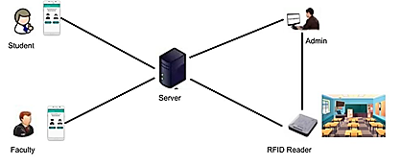

Figure 5.1: System Architecture for IoT based Smart College Campus using RFID

The above pictorial representation shows the various devices and their connections with other devices which provide the project the hardware as well as the storage requirements of this project. The server plays a key role in this system as it hosts the web application as well as handles the various requests from the devices. The servers will also have access to the current operational information to be sent usually as responses to the devices. It remains operational 24x7 so as to give the students and faculty service throughout the day. Hence, the server has to remain robust and have a very little downtime so as to provide seamless service and uninterrupted working of the system. The admin system also has to be connected to the server through a particular port so as to form a communication channel between them. This is provided by the Wi-Fi router, which provides signal connecting the various devices and providing a communication channel with the server through a communication port. The smart phones provide the user-interface for the faculty and students for the various functionalities provided by the system. They all communicate through the server which hosts the various functionalities provided by the system. The platform supported by our project currently is Android but can be expanded to various other platforms such as IOS, Windows, Firefox OS, etc. The RFID system plays a crucial role in the attendance module of our system.

Department of CSE, RNSIT2017-2018 Page 13

Chapter 5IoT Based Smart Campus

Hence, the RFID reader is placed outside or wherever convenient for the students to scan their provided RFID cards and enter the class. This RFID reader is connected to the server which automatically and instantly transmits the data collected on scanning by a RFID tag. There is no delay in this transmission, hence it provides a real-time sense of attendance monitoring. There is also usage of the faculty’s smart phone camera to provide the image of the class to give a head count of the class through image processing for double confirmation.

**5.2 Overall System Functionality**

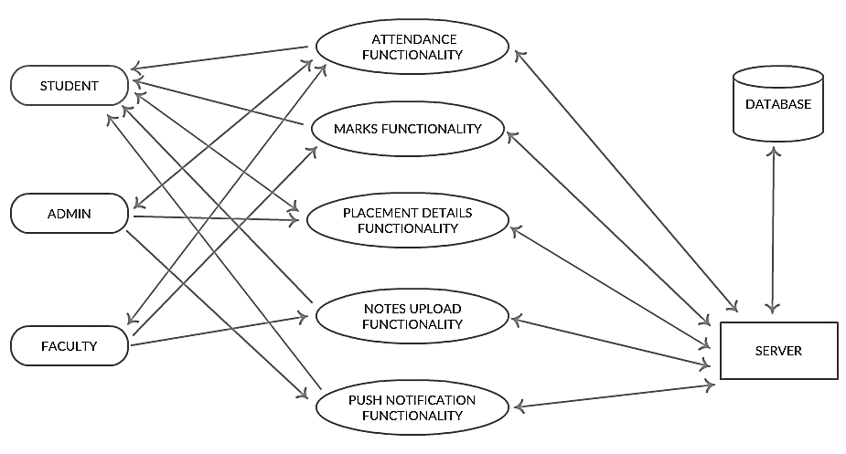As mentioned earlier, System design has to provide detailed description of the modules involved to achieve the various goals. This system provides various functionalities divided into modules which form the basis of the system design architecture. The various modules involve various actors on the scene according to their requirements, hence it is critical to design it meticulously and without a flaw as it will stand as the backbone of the entire system implementation and its final working. The below given block diagram provides the overall functionality design of the system.

Figure 5.2: Block Diagram of System Functionality

The block diagram shows the major modules in the system and their various actors which use or require these modules. All these modules require the server to carry out their working, hence all modules are associated with the server.

Department of CSE, RNSIT2017-2018 Page 14

Chapter 5IoT Based Smart Campus

The attendance functionality can be accessed by the student and the teachers from their smart phones for viewing and carrying out respectively. This attendance functionality also majorly involves the usage of RFID system and the camera. The marks functionality module provides the students to view their internal marks through their smart phones and the uploading part of this functionality is carried out by the faculty. Hence, they are associated with both student as well as faculty. The placement details functionality gives the students opportunity to know about the companies their eligible to apply. Hence, this functionality involves the admin who is authorized to enter the respected company details according to which students can view their companies. The notes upload functionality involves the faculty who can upload any important notes or handouts which can be retrieved by the student remotely through their app. This functionality also requires a major part to be played by the database in its working. The push notifications functionality is to provide required news and information to all students and faculty who have the app about the campus or related information in real time. This notification is handled by the admin who is authorized to send these notifications whenever required.

**5.3. Technologies used**

**5.3.1 Java**

Java is an object-oriented multithreaded programming language. It is designed to be small, simple and portable across different platforms as well as operating systems.

**5.3.1.1 Features of Java**

* Platform Independence: The Write-Once-Run-Anywhere ideal has not been achieved (tuning for different platforms usually required), but closer than with other languages.
* Object oriented throughout - no coding outside of class definitions, including main ().
* An extensive class library available in the core language packages.
* Compiler/Interpreter Combination.
* Code is compiled to byte codes that are interpreted by Java virtual machines (JVM).
* This provides portability to any machine for which a virtual machine has been written.
* The two steps of compilation and interpretation allow for extensive code checking and improved security.
* Robust Exception handling built-in, strong type checking (that is, all data must be declared an explicit type), local variables must be initialized.

Department of CSE, RNSIT2017-2018 Page 15

Chapter 5IoT Based Smart Campus

**5.3.1.2 Several features of C & C++ eliminated:**

* No memory pointers
* No pre-processor
* Array index limit checking

**5.3.1.3 Security**

* Programs run inside the virtual machine sandbox.
* Code pathologies reduced by

o Bytecode verifier - checks classes after loading

o Class loader - confines objects to unique namespaces.

**5.3.1.4 Dynamic Binding**

* The linking of data and methods to where they are located is done at run-time.
* New classes can be loaded while a program is running. Linking is done on the fly.
* Even if libraries are re-compiled, there is no need to recompile code that uses classes in those libraries. This differs from C++, which uses static binding. This can result in fragile classes for cases where linked code is changed and memory pointers then point to the wrong addresses.
* Interpretation of byte codes slowed performance in early versions, but advanced virtual machines with adaptive and just-in-time compilation and other techniques now typically provide performance up to 50% to 100% the speed of C++ programs.
* Threading Lightweight processes, called threads, can easily be spun off to perform multiprocessing.
* Can take advantage of multiprocessors where available
* Great for multimedia displays.
* Built-in Networking Java was designed with networking in mind and comes with many classes to develop sophisticated Internet communications.

**5.3.2. JSP (JAVA server pages)**

Java Server Pages (JSP) is a technology for developing Web pages that supports dynamic content. This helps developers insert java code in HTML pages by making use of special JSP tags, most of which start with <% and end with %>.

Department of CSE, RNSIT2017-2018 Page 16

Chapter 5IoT Based Smart Campus

A Java Server Pages component is a type of Java servlet that is designed to fulfil the role of a user interface for a Java web application. Web developers write JSPs as text files that combine HTML or XHTML code, XML elements, and embedded JSP actions and commands.

Using JSP, you can collect input from users through Webpage forms, present records from a database or another source, and create Web pages dynamically.JSP tags can be used for a variety of purposes, such as retrieving information from a database or registering user preferences, accessing JavaBeans components, passing control between pages, and sharing information between requests, pages etc.

JavaServer Pages often serve the same purpose as programs implemented using the Common Gateway Interface (CGI).

But JSP offers several advantages in comparison with the CGI.

* Performance is significantly better because JSP allows embedding Dynamic Elements in HTML Pages itself instead of having separate CGI files.
* JSP are always compiled before they are processed by the server unlike CGI/Perl which requires the server to load an interpreter and the target script each time the page is requested.
* JavaServer Pages are built on top of the Java Servlets API, so like Servlets, JSP also has access to all the powerful Enterprise Java APIs, including JDBC, JNDI, EJB, JAXP, etc.
* JSP pages can be used in combination with servlets that handle the business logic, the model supported by Java servlet template engines.

Department of CSE, RNSIT2017-2018 Page 17

Chapter 5IoT Based Smart Campus

**5.3.2.1 JSP architecture**

The web server needs a JSP engine, i.e., a container to process JSP pages. The JSP container is responsible for intercepting requests for JSP pages. This tutorial makes use of Apache which has built-in JSP container to support JSP pages development. A JSP container works with the Web server to provide the runtime environment and other services a JSP needs. It knows how to understand the special elements that are part of JSPs.

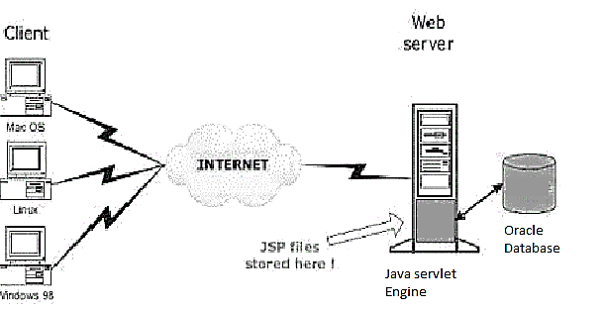

Figure 5.3: Position of JSP container and JSP files in a Web application

## 5.3.2.2 JSP Processing

The following steps explain how the web server creates the Webpage using JSP −

* As with a normal page, your browser sends an HTTP request to the web server.
* The web server recognizes that the HTTP request is for a JSP page and forwards it to a JSP engine. This is done by using the URL or JSP page which ends with .jsp instead of .html.
* The JSP engine loads the JSP page from disk and converts it into a servlet content. This conversion is very simple in which all template text is converted to println( ) statements and all JSP elements are converted to Java code. This code implements the corresponding dynamic behaviour of the page.
* The JSP engine compiles the servlet into an executable class and forwards the original request to a servlet engine.

Department of CSE, RNSIT2017-2018 Page 18

Chapter 5IoT Based Smart Campus

* A part of the web server called the servlet engine loads the Servlet class and executes it. During execution, the servlet produces an output in HTML format. The output is further passed on to the web server by the servlet engine inside an HTTP response.
* The web server forwards the HTTP response to your browser in terms of static HTML content.
* Finally, the web browser handles the dynamically-generated HTML page inside the HTTP response exactly as if it were a static page.

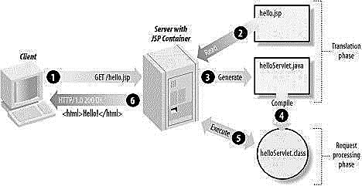

Figure 5.4: Steps in the creation of web application

Typically, the JSP engine checks to see whether a servlet for a JSP file already exists and whether the modification date on the JSP is older than the servlet. If the JSP is older than its generated servlet, the JSP container assumes that the JSP hasn't changed and that the generated servlet still matches the JSP's contents. This makes the process more efficient than with the other scripting languages (such as PHP) and therefore faster. So, in a way, a JSP page is really just another way to write a servlet without having to be a Java programming wiz. Except for the translation phase, a JSP page is handled exactly like a regular servlet.

Department of CSE, RNSIT2017-2018 Page 19

Chapter 5IoT Based Smart Campus

**5.3.3 Android**

Android is an open source and Linux-based Operating System for mobile devices such as smartphones and tablet computers. Android was developed by the Open Handset Alliance, led by Google, and other companies. Android offers a unified approach to application development for mobile devices which means developers need only develop for Android, and their applications should be able to run on different devices powered by Android. The source code for Android is available under free and open source software licenses. Google publishes most of the code under the Apache License version 2.0 and the rest, Linux kernel changes, under the GNU General Public License version 2.

**5.3.3.1 Why Android?**

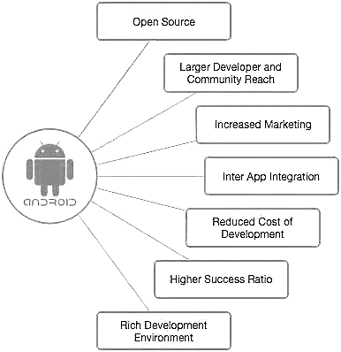

Figure 5.5: Advantages of Android

Android applications are usually developed in the Java language using the Android Software Development Kit. Once developed, Android applications can be packaged easily and sold out either through a store such as Google Play, SlideME, Opera Mobile Store, Mobango, F-droid and the Amazon Appstore.

Department of CSE, RNSIT2017-2018 Page 20

Chapter 5IoT Based Smart Campus

Android powers hundreds of millions of mobile devices in more than 190 countries around the world. It's the largest installed base of any mobile platform and growing fast. Every day more than 1 million new Android devices are activated worldwide.

Android operating system is a stack of software components which is roughly divided into five sections and four main layers as shown below in the architecture diagram.

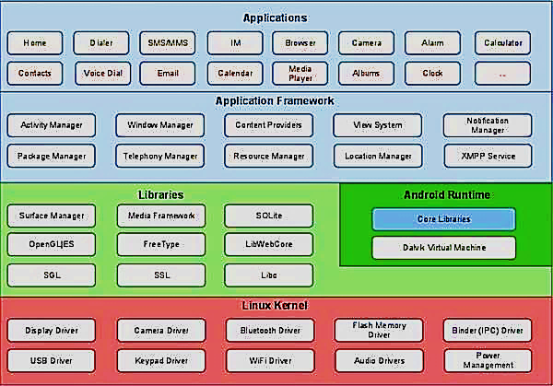

Figure 5.6: Android operating system components

Application components are the essential building blocks of an Android application. These components are loosely coupled by the application manifest file *AndroidManifest.xml* that describes each component of the application and how they interact.

There are following four main components that can be used within an Android application −

* **Activities:** They dictate the UI and handle the user interaction to the smartphone screen.
* **Services:** They handle background processing associated with an application.

Department of CSE, RNSIT2017-2018 Page 21

Chapter 5IoT Based Smart Campus

* **Broadcast Receivers:** They handle communication between Android OS and applications
* **Content Providers:** They handle data and database management issues.

Android Studio is the official IDE for android application development. It works based on IntelliJ IDEA.The following features are provided in the current stable version:

* [Gradle](https://en.wikipedia.org/wiki/Gradle)-based build support
* Android-specific [refactoring](https://en.wikipedia.org/wiki/Code_refactoring) and quick fixes
* [Lint](https://en.wikipedia.org/wiki/Lint_(software)) tools to catch performance, usability, version compatibility and other problems
* [ProGuard](https://en.wikipedia.org/wiki/ProGuard_(software)) integration and app-signing capabilities
* Template-based wizards to create common Android designs and components
* A rich [layout editor](https://en.wikipedia.org/wiki/Graphical_user_interface_builder) that allows users to drag-and-drop UI components, option to [preview layouts](https://en.wikipedia.org/wiki/WYSIWYG) on multiple screen configurations
* Support for building [Android Wear](https://en.wikipedia.org/wiki/Android_Wear) apps
* Built-in support for Google Cloud Platform, enabling integration with Firebase Cloud Messaging (Earlier 'Google Cloud Messaging') and Google App Engine
* Android Virtual Device (Emulator) to run and debug apps in the Android studio.

There are additional components which will be used in the construction of above mentioned entities, their logic, and wiring between them. These components are −

* **Fragments:** Represents a portion of user interface in an Activity.
* **Views:** UI elements that are drawn on-screen including buttons, lists forms etc.
* **Layouts:** View hierarchies that control screen format and appearance of the views.
* **Intents:** Messages wiring components together.
* **Resources:** External elements, such as strings, constants and drawable pictures
* **Manifest:** Configuration file for the application

**5.2.4 OPENCV with Java**

OpenCV is released under a BSD license and hence it is free for both academic and commercial use. It has C++, C, Python, and Java interfaces, and it supports Windows, Linux, Mac OS, iOS, and Android.

OpenCV was designed for computational efficiency and with a strong focus on real-time applications. Written in optimized C/C++, the library can take advantage of multi-core processing.

Department of CSE, RNSIT2017-2018 Page 22

Chapter 5IoT Based Smart Campus

Some of the basic features of OpenCV are described below:

* **Smoothing Images**: This involves applying Blur, Gaussian Blur, medianBlur, and bilateral Filter.
* **Eroding and Dilating:** It can apply two very common morphology operators: Dilation and Erosion.
* **Morphology Transformations:** OpenCV function morphologyEx to apply Morphological Transformation such as opening, closing, TopHat, and BlackHat etc.
* **Image Pyramids:** OpenCV functions pyrUp and pyrDown to down sample or up sample a given image
* **Basic Thresholding Operations:** It can perform basic thresholding operations using OpenCV function threshold.
* **Adding borders to your images:** OpenCV function copyMakeBorder is used to set the borders (extra padding to your image).
* **Remapping:** In OpenCV, the function remap offers a simple remapping implementation.
* **Histogram Calculation:** For simple purposes, OpenCV implements the function calcHist, which calculates the histogram of a set of arrays (usually images or image planes). It can operate with up to 32 dimensions.

Digital Image Processing (DIP) deals with manipulation of digital images using a digital computer. It is a subfield of signals and systems but focuses particularly on images. DIP focuses on developing a computer system that is able to perform processing on an image. The input of such system is a digital image. The system processes the image using efficient algorithms and gives an image as an output. Java is a high-level programming language that is widely used in the modern world. It can support and handle digital image processing efficiently using various functions.

Department of CSE, RNSIT2017-2018 Page 23

**Chapter 6**

**DETAILED DESIGN**

Campus Bridge project deals with various functionalities which it handles which are separated out as modules. Some of the main modules handled are:

* Attendance
* Marks
* Placement Details
* Notes and Circular Uploading
* Push Notifications

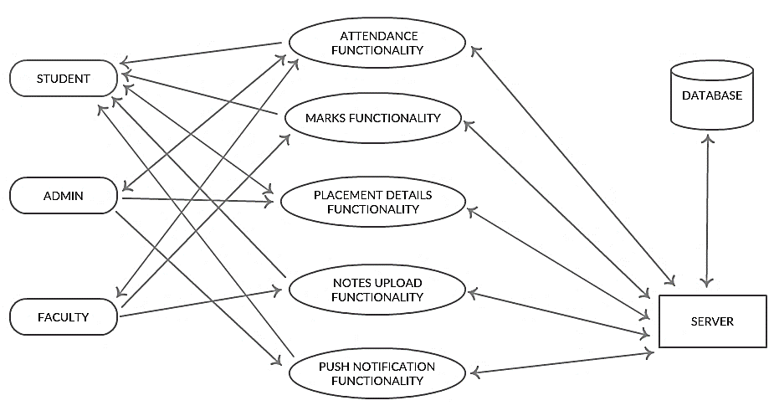

Figure 6.1: Main modules and their actors

These modules are carried out in various manners as illustrated with activity diagrams below.

**6.1 Attendance Functionality**

This functionality is a day-to-day basis or more a period-to-period carried out working. The main aim of this functionality is to reduce time wasted during attendance and also avoid proxies in class. The major role of this functionality is carried out by the RFID system in place. Each student has been assigned a unique RFID tag with a unique tag id to each of them. These tags are scanned by the RFID reader as they enter into the class. These entered RFID tag ids are instantly passed to the system by the reader.

Department of CSE, RNSIT2017-2018 Page 24

Chapter 6IoT Based Smart Campus

Usually the scanning distance has to be within 10 cm. This tag id’s and their associated USN are collected from the DB by the system and stored in a temporary table for that period. The associated and required details of the student is also retrieved by using the student USN from the student table. The next part of the working jumps to the faculty when the attendance has to be confirmed. The faculty opens the Campus Bridge app and logins with their respective credentials. The faculty selects the attendance section from their dashboard. This section requires to select the related subject code and section from the dropdown list which already holds the list of them handled by the faculty. Then, the selected subject code and section are sent to the system to be queried for the current list of students whose USN is available in the temporary table for that period. This USN list is dropped down along with checkboxes in the faculty app. The faculty is then prompted to capture a proper picture of the class which is sent automatically to the image processing system. The image processing system functions independently giving a head count of the class from the image. This number is tallied with the number of USN in the app list. If matched, the faculty directly updates the attendance for that period. If there is a difference, then faculty takes a proxy check and updates the attendance accordingly. Each of the USN with checked box, attendance for that particular subject is incremented by one. Student is provided the view attendance functionality in the app. The student enters into the app and into the attendance section. Here, the system automatically retrieves the section, semester and other required details from the database. The system queries the retrieved details to gather the various temporary table and subject-codes applicable to the student and automatically updates the attendance values in the main student table. This updated attendance values are displayed subject-code wise in the student app.

Department of CSE, RNSIT2017-2018 Page 25

Chapter 6IoT Based Smart Campus

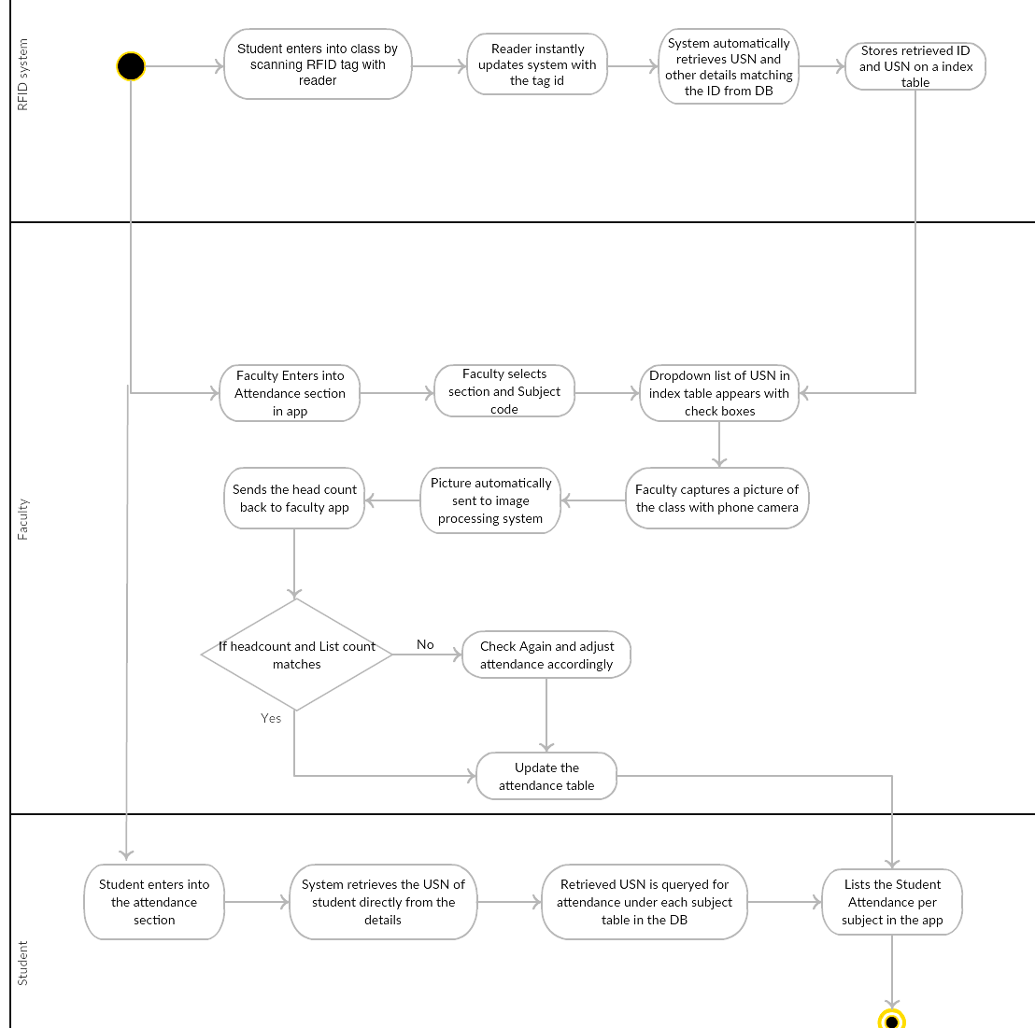

Figure 6.2: Attendance Functionality Module

**6.2 Marks Functionality**

This functionality is aimed at easy viewing and hassle-free updating of marks. This functionality starts with updating phase by each faculty. The faculty enters into the app along with the credentials. They are allowed to enter into the marks section in the app.

Department of CSE, RNSIT2017-2018 Page 26

Chapter 6IoT Based Smart Campus

This section requires them to select the subject-code and section from the dropdown list which already holds the list handled by them. These details are queried by the system to retrieve the list of students who have taken that subject in that section. The USN of these selected students are displayed on the app where the faculty selects individually and updates the marks for the particular internals.   Student enters into the app and into the marks functionality. The system automatically retrieves the various details from the USN of the system from the student table. The marks are also retrieved form the USN rom the student table with the help of subjects retrieved from the earlier working. These marks are displayed in the app subject-wise for each of the internals. Untaken or yet to be completed internals are displayed as 0 in the app.

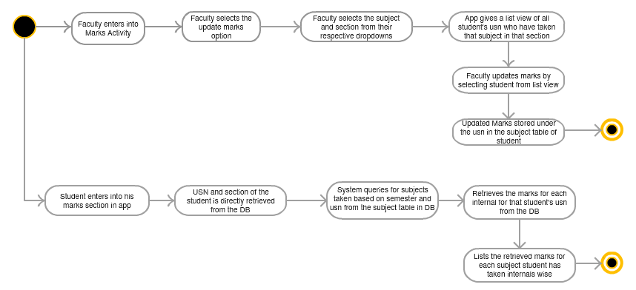

Figure 6.3: Marks Functionality Module

**6.3 Placement Details Functionality**

This functionality provides the various list of companies applicable to the student on his app with just his aggregate. The main aim is to provide the students with the students the various companies which they can look to seal a job and also to the junior years on the improvement to be done to achieve the various company interviews. The main role here is played by the admin.

Department of CSE, RNSIT2017-2018 Page 27

Chapter 6IoT Based Smart Campus

The admin enters the various company details such as the name of the company, Tier of the company, eligible branches which are stored in the placement database. Student enters into the app and the placement section. Here, the student is prompted to enter the current aggregate. This aggregate is used to filter the companies the student is eligible to apply. The tier of the company denotes the range of aggregate the student gas to score to apply for the company. The other required details such branch is taken automatically by the system. These details are queried accordingly and displays the list of companies on the app.

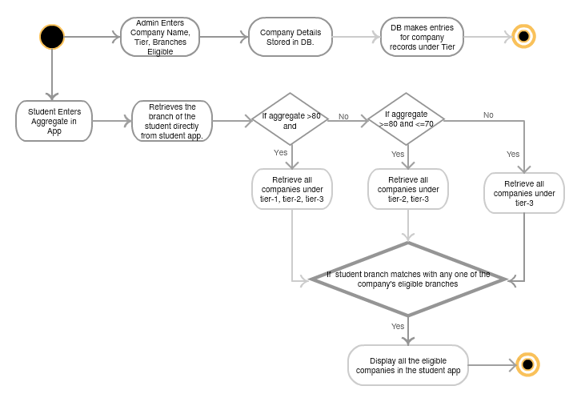

Figure 6.4: Placement Details Functionality Module

**6.4 Notes Upload Functionality**

The notes uploading functionality allows faculty to easily share their important notes and handouts with the students. Rather than like old times, where students queue up to take hard copy of notes outside shops, with the advent of smartphones into hands of students, having them in their phones is much more easy and feasible option. The faculty enters into the notes section in the app.

Department of CSE, RNSIT2017-2018 Page 28

Chapter 6IoT Based Smart Campus

The faculty is prompted to enter the semester and subject to which the notes belongs to. Then, the faculty selects the notes to be uploaded from the local storage of their phone. The notes are uploaded to the database under the entered semester and subject-code folder. The student enters into his notes functionality which lists the various notes under the semester that the student belongs to. The student selects the notes accordingly and it automatically downloaded into the local storage of their phone which can be accessed. Most of the formats are supported and allowed to be uploaded by the faculty.

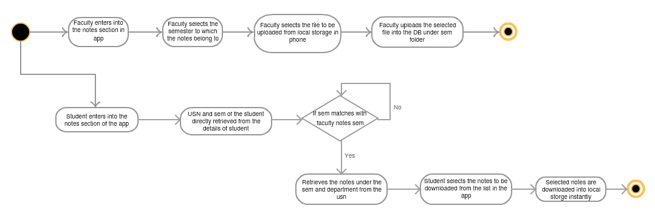

Figure 6.5: Notes Uploading Functionality Module

**6.5 Push Notification Functionality**

A push notification is a message that pops up on a mobile device. App publishers can send them at any time; users do not have to be in the app or using their devices to receive them. This push notifications functionality always provides a sense of convenience and value to the app users. In our Campus Bridge Project, the admin is entitled with the responsibility of handling all the push notifications to be sent to the faculty and the students. Our push notification setup is done by using the Google Firebase Cloud Messaging Service platform, which allows easier and convenient cross-platform messaging solution that lets you reliably deliver messages at no cost.

Department of CSE, RNSIT2017-2018 Page 29

Chapter 6IoT Based Smart Campus

An FCM implementation includes two main components for sending and receiving. First, a trusted environment such as Cloud Functions for Firebase or an app server on which to build, target, and send messages. Finally, an IOS, Android, or web (JavaScript) client app that receives messages. However, we have concentrated only on the Android Platform for our project. Thus, the admin has to login to his firebase console and select the cloud messaging option. This will lead him to a compose message page where the admin can enter the message along with many various options such as delayed delivery, topic subscription and send the message. The push notification is sent to every phone that has app either running in the foreground or background. Thus, students and faculty can be updated about events or any important information through this functionality in real time literally. Push Notifications also provide a cost-effective method over SMS or emails, as they can be sent free of cost and without remembering any phone numbers or email-ids as required for the other means of communication respectively.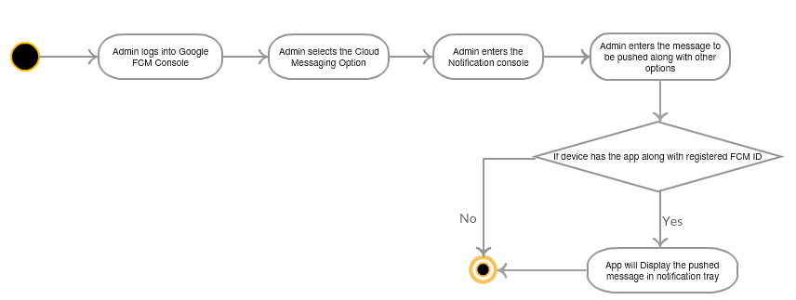

Figure 6.6: Push Notification Functionality Module

Department of CSE, RNSIT2017-2018 Page 30

Chapter 6IoT Based Smart Campus

**6.6 Entity relationships for the Proposed System**

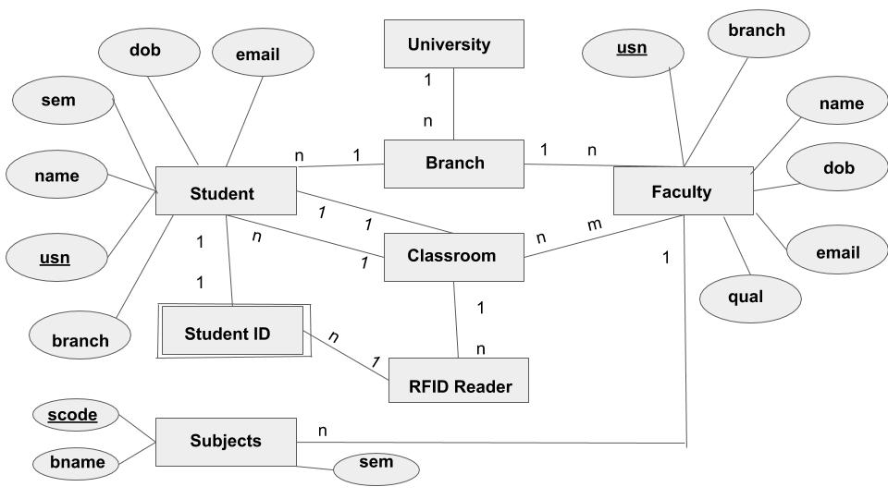Figure 6.7: E-R Diagram for the relationships between the students and faculty

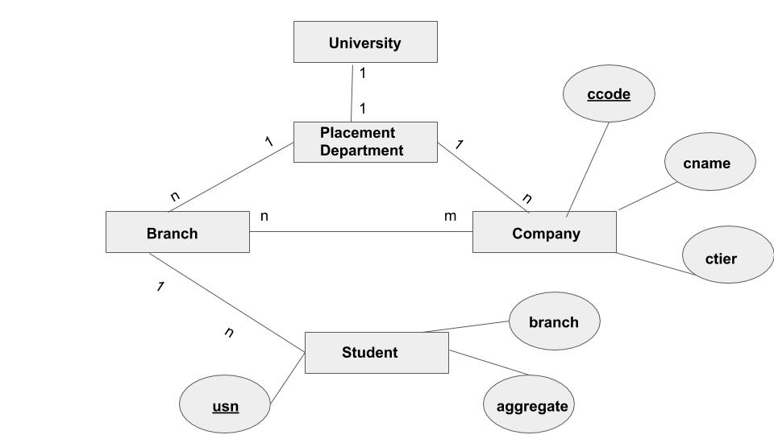

Figure 6.8: E-R diagram for the relationship between students and the placement department

Department of CSE, RNSIT2017-2018 Page 31

Chapter 6IoT Based Smart Campus

**6.7 Level diagrams for the system**

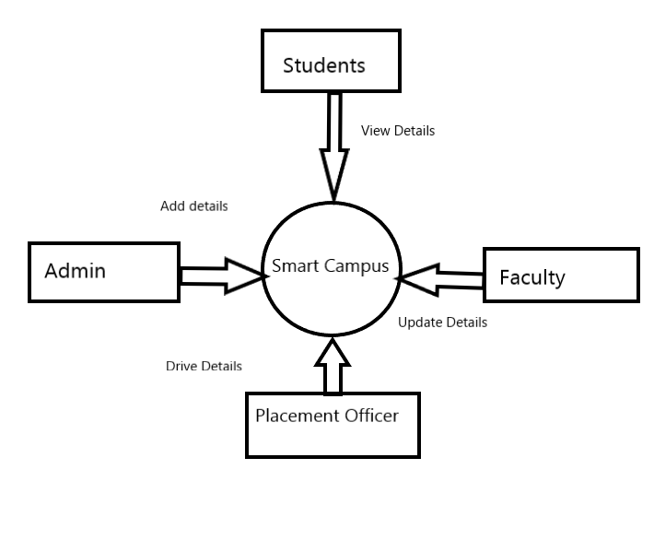

Figure 6.9: Level-0

Smart campus provides a lot of functionalities to its users. Faculty can update information and the updated information can be viewed by students. Admin can update details regarding any faculty or student. Placement officer can inform candidates about the drives happening in campus.

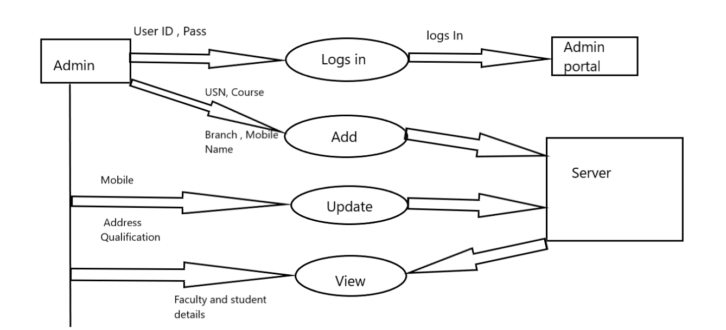

Figure 6.10: Level-1

Department of CSE, RNSIT2017-2018 Page 32

Chapter 6IoT Based Smart Campus

Admin has been provided with a web portal to login and perform various actions. His/her user ID and passwords are validated if the right user details are entered Login becomes successful. Admin has been provided with a few functionalities like: ADD, VIEW, UPDATE, DELETE and sending PUSH NOTIFICATIONS.

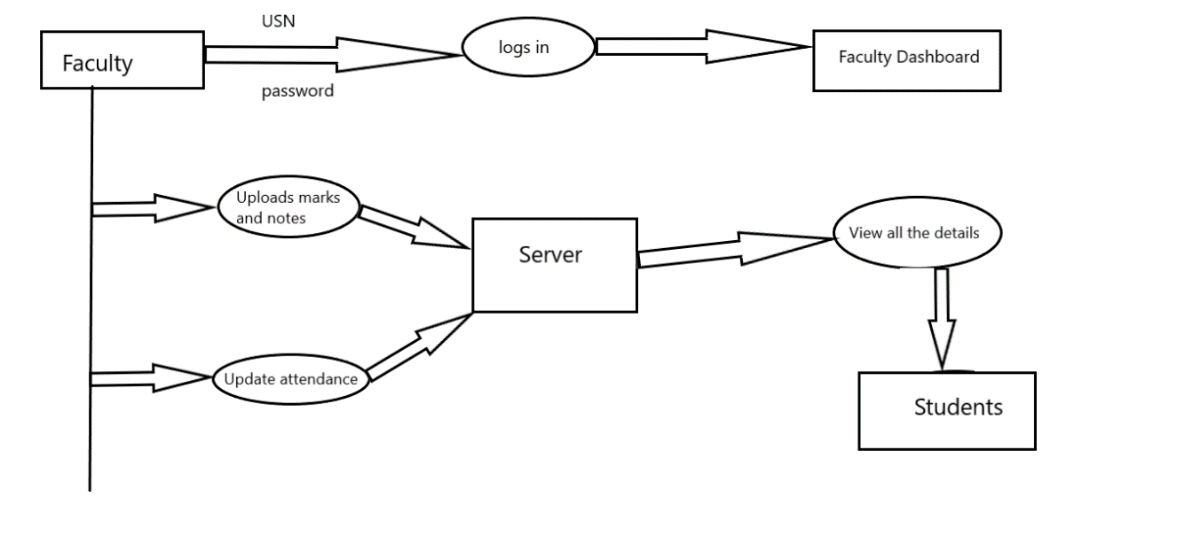

6.11: Level-2

A faculty can use his android application to login and update internal marks, notes and attendance details. The update will directly reflect in the server database.

**6.8 RFID (Radio Frequency and Identification)**

The project handles the attendance monitoring by using the RFID technology.

RFID is an acronym for “radio-frequency identification” and refers to a technology whereby digital data encoded in RFID tags are captured by a reader via radio waves.

RFID methods utilize radio waves to accomplish this. At a simple level, RFID systems consist of three components: an RFID tag, an RFID reader, and an antenna. RFID tags contain an integrated circuit and an antenna, which are used to transmit data to the RFID reader (also called an interrogator). The reader then converts the radio waves to a more usable form of data. Information collected from the tags is then transferred through a communications interface to a host computer system, where the data can be stored in a database and analysed at a later time. The tag is also composed of a protective material that holds the pieces together and shields them from various environmental conditions.

Department of CSE, RNSIT2017-2018 Page 33

Chapter 6IoT Based Smart Campus

RFID tags come in a variety of shapes and sizes and are either passive or active. A passive tag is an RFID tag that does not contain a battery; the power is supplied by the reader.When radio waves from the reader are encountered by a passive RFID tag, the coiled antenna within the tag forms a magnetic field. The tag can be read only at very short distances, typically a few feet at most.

Passive tags are the most widely used, as they are smaller and less expensive to implement. Active RFID tags have a transmitter and their own power source (typically a battery). The power source is used to run the microchip's circuitry and to broadcast a signal to a reader (the way a cell phone transmits signals to a base station).

In the project, an USB RFID reader and passive RFID tags have been used which are mapped to student’s USN. When the student arrives for his/her class , he/she scans his/her RFID tag against the reader placed outside the class. His/her USN is marked present for that particular class. Upon even occurrences of the scans of the tags, his/her attendance are successfully unchecked. In this way, student’s attendance is noted. RFID, however, has several advantages over systems that use barcode asset tracking software. The most notable is that RFID tag data can be read outside the line-of-sight, whereas barcodes must be aligned with an optical scanner.

**6.9 Internet of Things**

To make the accessing of the information related to the university easier, the concept of IoT is adapted is a structure in which objects, people are provided with exclusive identity and the ability to relocate data over a network without requiring two-way handshaking between human-to-human or human-to-computer interaction.

Smart campus is a trendy application in the paradigm of the IoT. The concept of constructing a smart campus implies that the institution will adopt advanced technologies to automatically monitor and control every facility on campus. The design and the implementation of smart campus is different with others, depends on the campus needs. The infrastructures to build a smart campus is costly. However, when it is implemented, all the campus activities will be effective and efficient. IoT which bases on the internet, uses a variety of information sensing identification device and information processing equipment, such as RFID, GPS, GIS, JIT, EDI and other devices to combine with the internet to form an extensive network in order to achieve information and intelligence for entity.

Department of CSE, RNSIT2017-2018 Page 34

Chapter 6IoT Based Smart Campus

The project proposes the solution of RFID design structure integrated by using modern technology from internet, supported by good quality technology and economy. This technology supports things to increase the campus security, asset track record, valuable things, student record etc. To promote remote accessing of information by the students, faculties, an application has been developed to enable students to view his information related to academics, placements, aggregate etc and also get notified about circulars or messages put up by the university via push notifications by the admin through Firebase. Teachers can view and update the marks of the students; monitor the attendance and also provide the study materials by uploading the notes. Thus, manual work is reduced to a great extent and made available at the server which facilitates remote access.

Department of CSE, RNSIT2017-2018 Page 35

**Chapter 7**

**IMPLEMENTATION**

The project implements Android Studio, MySQL 5.1, Navicat for MySQL, HTML, CSS, JAVA. JDBC API is used for connectivity between the Java programming language and MySQL and Bootstrap has been used for front end. The project is capable of running on standard internet web browsers. The interface is used to bridge the gap between students, teachers and the administration.

**7.1 Actors on the scene**

* Students
* Faculty
* Admin

1. **Admin**

A login page welcomes the admin where in the credentials of admin must be input. Once, the credentials match the data stored in the dB the admin ‘s login is successful and will be lead to the next page.  The query written interacts with the admin_ information table to verify whether right details have been inserted. As said before on successful login the admin is lead to his home page from the login page. The pages are named as home.jsp and login .jsp in NetBeans. The home page has a navbar towards its left and a home screen welcoming the administrator. The functionality of the navbar us to traverse the admin through the website and thus he will witness the various tasks he is able to perform. The options included in the navbar are Functionality, Placements, Attendance, and Logout.

1. **Functionality:** Choosing this option will scroll down to show the above picture. The admin is now able to add, delete, and view any student or faculty’s details. The UI is comforting rather than the old school methods. On hovering on a student’s image or a faculty’s image the add, delete, view operations appear, on clicking any one of these will give away a form for the user to fill in the necessary details.

Department of CSE, RNSIT2017-2018 Page 36

Chapter 7IoT Based Smart Campus

USN is required to view a student or a faculty details or to delete of their details. Once, the USN is inserted the individual’s details pops up on the screen. The details contain every field in the form must be filled out for successful updation and addition.

Query communicates with tables named “student_information” &

“ faculty_information”.

* **View** – Incase the admin wants to retrieve information about a student or a faculty, view button does the job. When View button is clicked and the USN is entered all the necessary data is fetched from the tables.
* **Add** – On clicking the add button a form fills in the screen the admin has to fill in all the fields for successful addition of the individual into the system database.
* **Delete**- If a person has to be eliminated or removed from the dB delete button has to be clicked, entering the USN and clicking submit will delete the data successfully from the respective tables.
* **Update**- USN acts as a primary key in updating a person’s details. The form is popped up again and the required fields can be updates for the person.

1. **Placements:** The placements option presents different fields for the admin to enter various companies visiting the campus and their requirements. The fields included are: Company name, Branches the company prefer, company code, company tier. Companies have been classified into various tires based of their perecentage requirement. The company_details table and the ctype tables are queried to add information.
2. **Attendance:**  This section is used assign RFID to every student. The RFID reader detects the tag and the student is assigned with a unique ID.
3. **Logout:** On clicking logout the admin is directed back to the login page and thus he signs off.

Department of CSE, RNSIT2017-2018 Page 37

Chapter 7IoT Based Smart Campus

**2) Students and Faculty**

While the admin is provided with a website, working on desktop the students as well as faculties are provided with an android app. Android studio has been used to implement this application. Initially, a login page has been set up to read the credentials of the person, as per the data received the individual will be classified into a faculty or a student. If it is a faculty then UI, flow differs from that of the students.

**Faculty** – He / she will be able to update attendance and marks of students. The faculty can also upload notes for the students in the application. When the faculty clicks on marks, a new page is shown where a drop down of all the subjects he/she handles is thrown and the sections taught must be chosen. Once, the choices are made a list view is seen where in all the students’ USN is show, the faculty just have to tap on the USN to enter the marks and on clicking submit all the students’ marks are been uploaded. The “assign_fac” table contains details of each faculty’s subjects and the sections they handle. Thus, we make use of this table to fetch the required content. RFID tags have been used to handle attendance. Every student scans their RFID before entering the class. Once, the faculty opens the app the attendance for all the students is already marked (i.e., a tick mark against every student’s USN in the class). The app also gives the total number of students present in the class as well. The project also involves a camera, which takes the picture of all the class and returns the head count if there is any mismatch between the camera count, and the total attendance count returned by the app the teacher could always re check. The attendance update is initially stored in a “temp_attendance” table. Later, the attendance for that particular subject is updated in the respective subject’s table.

**Student** – Student is given four options of viewing his Marks, attendance, placements details and finally downloading the notes. A tap on Marks will view the score gained by the student in each internal assessment. The table gives us the marks taken in every subject in that semester. Placements option gives an idea of students’ eligibility, he/she can enter his percentage to check out the companies they can apply or are eligible for. Notes section gives away all the notes uploaded by the teacher for that semester.

Department of CSE, RNSIT2017-2018 Page 38

Chapter 7IoT Based Smart Campus

The app also provides a navbar that on clicking helps one update his personal information or upload his/ her image. The students can also check their overall aggregate by the option provided. It also provides the Logout option for the user to end his session.

**7.2. Algorithms Used**

**7.2.1 Attendance**

**Algorithm1** Attendance details

**Input:** Students’s USN retrieved from temp_attendance

**Output:** Attendance count for each subject

1: Teacher logs in.

2: The students list pops out for his subject from the

temp_attendance table and proxy checking is

performed.

3: **if** (*number of students captured by the*

*camera) = (number of students in the list)* **then**

4: Teacher clicks on update to store into the

Final attendance table.

5: **else**

Teacher checks for those who were absent, unchecks them and updates.

6: **endif**

7**: end**

**7.2.2 Marks**

**Algorithm2** View and updation of marks by student and

faculty

**Input:** Subject wise marks of the students and list of

students of a class

**Output:** Marks for the subject corresponding to the

student is viewed. Marks are viewed and

updated by the faculty.

1: Teacher or student logs in.

2: Student navigates to the marks section and selects

the subject.

3: Marks of IA1, IA2, IA3 are viewed.

4: Teacher navigates to the marks section

5: **if** (*he selects view functionality)* **then**

6: He selects the subject code.

7**:** Marks along with student’s USN is viewed.

8: **else**

**9:** He selects update functionality.

10: He selects subject and class.

11: List of students with USN and marks is displayed.

12: Faculty clicks on a USN and insert marks.

13: Marks are updated.

14: **endif**

15: **end**

Department of CSE, RNSIT2017-2018 Page 39

Chapter 7IoT Based Smart Campus

**7.2.3 Placement details**

**Algorithm3** Placement details for the students

**Input:** Student’s aggregate

**Output:** List of companies the student is eligible for.

1: Student logs in.

2: Student navigates to placement page.

3: He enters his aggregate

4: **if (***aggregate >= 75)* **then**

5: T1, T2, T3companies are displayed.

6: **endif**

7: **if (***aggregate >= 60)* **then**

8**:** T2, T3companies are displayed.

9: **endif**

10: **if (***aggregate >= 50)* ***then***

11**:** T3companies are displayed.

12: **else**

13: It displays “NOT ELIGIBLE”.

14: **endif**

15: **end**

**7.2.4 Notes uploading and downloading**

**Algorithm4** Notes upload and download

**Input:** Notes to be available in (.pdf) format

**Output:** Notes downloaded into the local device by the student or

uploaded to the server by the faculty

1: Student or faculty logs in.

2: Student or faculty navigates to notes section.

3: **if** (*student navigates to notes section*) **then**

4: A list of notes is shown.

5: Student selects the notes and it is downloaded.

6: **endif**

7: **if (***faculty navigates to notes section)* **then**

8**:** He selects the semester.

9: he selects the file (.pdf).

10:Uploads it.

11**:** **endif**

12: **end**

Department of CSE, RNSIT2017-2018 Page 40

Chapter 7IoT Based Smart Campus

**7.3. Source Code**

**Android**

**//student requests for attendance**

@Override

protected String doInBackground(URL... urls) {

try {

URL url = new URL(RegURL.url + "getStudAtt");

JSONObject jsn = new JSONObject();

jsn.put("USN", sUSN);

jsn.put("sem", ssem);

res = HttpClientConnection.executeClient(url, jsn);

} catch (MalformedURLException e) {

e.printStackTrace();

} catch (JSONException e) {

e.printStackTrace();

} catch (IOException e) {

e.printStackTrace();

}

return res;

}

**//student view attendance from servlet**

@Override

public View getView(int position, View convertView, ViewGroup parent) {

listPosititon = position;

ViewHolder viewHolder = null;

if (convertView == null) {

LayoutInflater inflator = context.getLayoutInflater();

convertView = inflator.inflate(R.layout.rowattendance, null);

viewHolder = new ViewHolder();

viewHolder.tUSN = convertView.findViewById(R.id.tvUSN);

viewHolder.tname = convertView.findViewById(R.id.tvname);

viewHolder.chbox= convertView.findViewById(R.id.chkbox);

convertView.setTag(viewHolder);

convertView.setTag(R.id.tvUSN, viewHolder.tUSN);

convertView.setTag(R.id.tvname, viewHolder.tname);

convertView.setTag(R.id.chkbox, viewHolder.chbox);

}

Department of CSE, RNSIT2017-2018 Page 41

Chapter 7IoT Based Smart Campus

else {

viewHolder = (ViewHolder) convertView.getTag();

}

viewHolder.tUSN.setTag(position); // This line is important.

viewHolder.tname.setTag(position);

viewHolder.chbox.setTag(position);

viewHolder.tUSN.setText(list.get(position).getUSN());

viewHolder.tname.setText(list.get(position).getName());

viewHolder.chbox.setChecked(list.get(position).getStatus());

return convertView;

}

**//Faculty checks attendance**

@Override

protected void onCreate(Bundle savedInstanceState) {

super.onCreate(savedInstanceState);

setContentView(R.layout.activity_fac_attendance);

USN=getIntent().getExtras().getString("USN");

lv=findViewById(R.id.classlist);

new fetchsec().execute();

try {

Thread.sleep(2000);

} catch (InterruptedException e) {

e.printStackTrace();

}

response=response.trim().substring(1,response.length()-1);

flist=response.split(",");

for(int i =0;i<flist.length;i=i+2)

{

sec.add(flist[i+1]);

section.append(flist[i+1]);

subcode.append(flist[i]);

}

//Toast.makeText(this, section.toString()+subcode.toString(), Toast.LENGTH_SHORT).show();

adapter=new ArrayAdapter<String>(FacAttendanceActivity.this,R.layout.activity_list_view,R.id.ltxtview,sec);

lv.setAdapter(adapter);

lv.setClickable(true);

lv.setOnItemClickListener(new AdapterView.OnItemClickListener() {

@Override

public void onItemClick(AdapterView<?> arg0, View arg1, int position, long arg3) {

Object o = lv.getItemAtPosition(position);

str=(String)o;//As you are using Default String Adapter

Intent i =new Intent(FacAttendanceActivity.this,FacAttendanceUpdateActivity.class);

Department of CSE, RNSIT2017-2018 Page 42

Chapter 7IoT Based Smart Campus

i.putExtra("USN",USN);

i.putExtra("section",str);

i.putExtra("strsec",section.toString());

i.putExtra("strscode",subcode.toString());

startActivity(i);

}

});

}

**//faculty updates the attendance**

@Override

protected void onCreate(Bundle savedInstanceState) {

super.onCreate(savedInstanceState);

setContentView(R.layout.activity_fac_attendance_update);

section=getIntent().getExtras().getString("section");

fullsec=getIntent().getExtras().getString("strsec");

facUSN=getIntent().getExtras().getString("USN");

fullscode=getIntent().getExtras().getString("strscode");

subjspin=findViewById(R.id.subjcode);

lv=findViewById(R.id.attlist);

cap=findViewById(R.id.capture);

update=findViewById(R.id.attup);

String [] sec=fullsec.trim().split(" ");

String [] sub=fullscode.trim().split(" ");

subj = new ArrayAdapter(FacAttendanceUpdateActivity.this,android.R.layout.simple_spinner_item,sub);

subj.setDropDownViewResource(android.R.layout.simple_spinner_dropdown_item);

subjspin.setAdapter(subj);

subjspin.setOnItemSelectedListener(new AdapterView.OnItemSelectedListener() {

@Override

public void onItemSelected(AdapterView<?> parent, View view, int position, long id) {

strsubj = parent.getItemAtPosition(position).toString();

}

@Override

public void onNothingSelected(AdapterView<?> adapterView) {

}

});

new fetchtempatt().execute();

try {

Thread.sleep(2000);

} catch (InterruptedException e) {

e.printStackTrace();

}

Department of CSE, RNSIT2017-2018 Page 43

Chapter 7IoT Based Smart Campus

Toast.makeText(this, resp, Toast.LENGTH_SHORT).show();

resp=resp.substring(1,resp.length()-1);

String [] attlist=resp.split(",");

lv.setChoiceMode(ListView.CHOICE_MODE_MULTIPLE);

lv.setTextFilterEnabled(true);

adapter=new ArrayAdapter<String>(this,R.layout.simple_checked_list_item,attlist);

lv.setAdapter(adapter);

lv.setClickable(true);

for(int i=0;i<attlist.length;i++)

lv.setItemChecked(i,true);

lv.setOnItemClickListener(new AdapterView.OnItemClickListener() {

@Override

public void onItemClick(AdapterView<?> arg0, View arg1, final int position, long arg3) {

Object o = lv.getItemAtPosition(position);

String str = (String) o;//As you are using Default String Adapter

CheckedTextView item = (CheckedTextView) arg1;

Toast.makeText(FacAttendanceUpdateActivity.this, lv.getCount()+""+item.isChecked()+""+position + " "+str, Toast.LENGTH_SHORT).show();

}

});

update.setOnClickListener(new View.OnClickListener() {

@Override

public void onClick(View v) {

for(int i=0;i<lv.getCount();i++)

{

if(lv.isItemChecked(i))

{

String b="true";

hmap.put(lv.getAdapter().getItem(i).toString(),b);

}

else

{

String b="false";

hmap.put(lv.getAdapter().getItem(i).toString(),b);

}

}

ArrayList<Map.Entry<String, String>> arrayList = new ArrayList<>();

Set set=hmap.entrySet();

Department of CSE, RNSIT2017-2018 Page 44

Chapter 7IoT Based Smart Campus

Iterator i =set.iterator();

while(i.hasNext()) {

Map.Entry mentry = (Map.Entry)i.next();

if(mentry.getValue().equals("true")) {

s.append(mentry.getKey());

s.append(",");

}

}

Toast.makeText(FacAttendanceUpdateActivity.this,"Updated Successfully", Toast.LENGTH_SHORT).show();

new addatt().execute();

update.setClickable(false);

}

});

cap.setOnClickListener(new View.OnClickListener() {

@Override

public void onClick(View v) {

Intent cameraIntent = new Intent(android.provider.MediaStore.ACTION_IMAGE_CAPTURE);

startActivityForResult(cameraIntent, CAMERA_REQUEST);

}

});

}

protected void onActivityResult(int requestCode, int resultCode, Intent data) {

if (requestCode == CAMERA_REQUEST && resultCode == Activity.RESULT_OK) {

Bitmap bm = (Bitmap) data.getExtras().get("data");

Toast.makeText(this, "<><><> "+bm.getHeight()+""+bm.getHeight(), Toast.LENGTH_SHORT).show();

//imageView.setImageBitmap(photo);

(int)(bm.getHeight()*0.5), true);

ByteArrayOutputStream baos = new ByteArrayOutputStream();

bm.compress(Bitmap.CompressFormat.JPEG, 100, baos);

Toast.makeText(this, " "+bm.getHeight()+""+bm.getHeight(), Toast.LENGTH_SHORT).show();

byte[] b = baos.toByteArray();

imgString = Base64.encodeToString(b, Base64.DEFAULT);

URL url = null;

try {

url = new URL(RegURL.url + "Headcount");

} catch (MalformedURLException e) {

e.printStackTrace();

}

new SendPic().execute(url);

}

}

private class SendPic extends AsyncTask<URL, Void, String> {

@Override

Department of CSE, RNSIT2017-2018 Page 45

Chapter 7IoT Based Smart Campus

protected String doInBackground(URL... urls) {

try {

URL url = urls[0];

JSONObject jsn = new JSONObject();

jsn.put("img", imgString);

String response = HttpClientConnection.executeClient(url, jsn);

ires = response;

} catch (MalformedURLException e) {

e.printStackTrace();

} catch (JSONException e) {

e.printStackTrace();

} catch (IOException e) {

e.printStackTrace();

}

return ires;

} @Override

protected void onProgressUpdate(Void... values) {

super.onProgressUpdate(values);

}

@Override

protected void onPostExecute(String s) {

super.onPostExecute(s);

Toast.makeText(FacAttendanceUpdateActivity.this, ires, Toast.LENGTH_SHORT).show();

}

}

**//student requests for marks**

public class fetch_section extends AsyncTask<URL, Void, String> {

@Override

protected String doInBackground(URL... urls) {

try {

URL url = new URL(RegURL.url + "Student");

JSONObject jsn = new JSONObject();

jsn.put("USN", USN);

jsn.put("sem",sem);

jsn.put("ia",ia);

res = HttpClientConnection.executeClient(url, jsn);

} catch (MalformedURLException e) {

e.printStackTrace();

} catch (JSONException e) {

e.printStackTrace();

} catch (IOException e) {

e.printStackTrace();

}

Department of CSE, RNSIT2017-2018 Page 46

Chapter 7IoT Based Smart Campus

return res;

}

**//faculty view marks**

@Override

protected String doInBackground(URL... urls) {

try {

URL url = new URL(RegURL.url + "StudDetails");

JSONObject jsn = new JSONObject();

jsn.put("scode",scode );

jsn.put("section",semval );

res = HttpClientConnection.executeClient(url, jsn);

} catch (MalformedURLException e) {

e.printStackTrace();

} catch (JSONException e) {

e.printStackTrace();

} catch (IOException e) {

e.printStackTrace();

}

return res;

}

**//faculty update marks**

getbtn.setOnClickListener(new View.OnClickListener() {

@Override

public void onClick(View view) {

new FacUpdateMarks.GetStudInfo().execute();

try {

Thread.sleep(2000);

} catch (InterruptedException e) {

e.printStackTrace();

}

sresponse= sresponse.substring(1,sresponse.length()-1);

Toast.makeText(FacUpdateMarks.this, sresponse, Toast.LENGTH_SHORT).show();

String USN[]= sresponse.split(",");

ArrayAdapter<String>adapter=new ArrayAdapter<String>(FacUpdateMarks.this,R.layout.activity_list_view,R.id.ltxtview,USN);

StrictMode.ThreadPolicy policy = new StrictMode.ThreadPolicy.Builder().build();

StrictMode.setThreadPolicy(policy);

final HashMap<String,String> hmap= new HashMap<>();

lv.setAdapter(adapter);

lv.setClickable(true);

lv.setOnItemClickListener(new AdapterView.OnItemClickListener() {

Department of CSE, RNSIT2017-2018 Page 47

Chapter 7IoT Based Smart Campus

@Override

public void onItemClick(AdapterView<?> arg0, View arg1, final int position, long arg3) {

Object o = lv.getItemAtPosition(position);

str=(String)o;//As you are using Default String Adapter

Toast.makeText(FacUpdateMarks.this,position+"",Toast.LENGTH_SHORT).show();

final EditText txt = new EditText(FacUpdateMarks.this);

AlertDialog.Builder builder = new AlertDialog.Builder(FacUpdateMarks.this);

builder.setTitle("Enter Marks");

builder.setView(txt);

builder.setPositiveButton("OK", new DialogInterface.OnClickListener()

{

@Override

public void onClick(DialogInterface dialog, int which) {

String name = txt.getText().toString();

Toast.makeText(FacUpdateMarks.this,name,Toast.LENGTH_SHORT).show();

hmap.put(str,name);

}

});

builder.setNegativeButton("Cancel", new DialogInterface.OnClickListener() {

@Override

public void onClick(DialogInterface dialog, int which) {

dialog.cancel();

}

})

builder.show();

}

});

updatebtn.setOnClickListener(new View.OnClickListener() {

@Override

public void onClick(View view) {

ArrayList<Map.Entry<String, String>> arrayList = new ArrayList<>();

arrayList.addAll(hmap.entrySet());

Log.i("qwerty ",arrayList.toString());

Toast.makeText(FacUpdateMarks.this, "\n"+arrayList.toString(), Toast.LENGTH_SHORT).show();

URL url = null;

try {

url = new URL(RegURL.url+"FacUpdateMarks");

JSONObject jsn= new JSONObject();

jsn.put("upmarks",arrayList);

jsn.put("sem",strsem);

jsn.put("scode",strscode);

jsn.put("ia",ia);

response= HttpClientConnection.executeClient(url, jsn);

Department of CSE, RNSIT2017-2018 Page 48

Chapter 7IoT Based Smart Campus

Toast.makeText(FacUpdateMarks.this, response, Toast.LENGTH_SHORT).show();

} catch (MalformedURLException e) {

e.printStackTrace();

} catch (IOException e) {

e.printStackTrace();

} catch (JSONException e) {

e.printStackTrace();

}

}

});

}

});

}

@Override

protected void onPostExecute(String res) {

res=res.substring(1,res.length()-1);

Toast.makeText(Fac_View_Marks.this,res,Toast.LENGTH_LONG).show();

arr= res.split(",");

List<Model> list= new ArrayList<Model>();

for(int i=0; i < arr.length; i+=4) {

list.add(new Model(""+arr[i].trim(),arr[i+1]+"\t"+arr[i+2]+"\t"+arr[i+3]));

}

adapter = new MyAdapter(Fac_View_Marks.this,list);

listView.setAdapter(adapter);

}

}

**//student downloads the notes**

@Override

protected String doInBackground(String... f_url) {

int count;

try {

URL url = new URL(f_url[0]);

URLConnection conection = url.openConnection();

conection.connect();

int lenghtOfFile = conection.getContentLength();

// download the file

InputStream input = new BufferedInputStream(url.openStream(), 8192);

// Output stream

OutputStream output = new FileOutputStream(folder+"/"+str);

Department of CSE, RNSIT2017-2018 Page 49

Chapter 7IoT Based Smart Campus

byte data[] = new byte[1024];

long total = 0;

while ((count = input.read(data)) != -1) {

total += count;

publishProgress(""+(int)((total*100)/lenghtOfFile));

output.write(data, 0, count);

}

output.flush();

output.close();

input.close();

} catch (Exception e) {

Log.e("Error: ", e.getMessage());

}

return null;

}

**//faculty uploads the notes**

public void uploadFile(String sourceFileUri) {

String serverResponseMessage = "";

String upLoadServerUri = RegURL.url + "FacUploadData";

String fileName = sourceFileUri;

HttpURLConnection conn = null;

DataOutputStream dos = null;

String lineEnd = "\r\n";

String twoHyphens = "--";

String boundary = "*****";

int bytesRead, bytesAvailable, bufferSize;

byte[] buffer;

int maxBufferSize = 10 * 1024 * 1024;

File sourceFile = new File(sourceFileUri);

if (!sourceFile.isFile()) {

Log.e("uploadFile", "Source File Does not exist");

}

try {

FileInputStream fileInputStream = new FileInputStream(sourceFile);

URL url = new URL(upLoadServerUri);

conn = (HttpURLConnection) url.openConnection(); // Open a HTTP connection to the URL

conn.setDoInput(true); // Allow Inputs

conn.setDoOutput(true); // Allow Outputs

conn.setUseCaches(false); // Don't use a Cached Copy

conn.setRequestMethod("POST");

conn.setRequestProperty("Connection", "Keep-Alive");

Department of CSE, RNSIT2017-2018 Page 50

Chapter 7IoT Based Smart Campus

conn.setRequestProperty("ENCTYPE", "multipart/form-data");

conn.setRequestProperty("Content-Type", "multipart/form-data;boundary=" + boundary);

conn.setRequestProperty("uploaded_file", fileName);

dos = new DataOutputStream(conn.getOutputStream());

dos.writeBytes(twoHyphens + boundary + lineEnd);

//dos.writeUTF("Content-Disposition: form-data; name=\"lat\";lat=\""+ lat + "\"" + lineEnd);

// dos.writeUTF(lon);

dos.writeBytes("Content-Disposition: form-data; name=\"uploaded_file\";filename=\"" + fileName + "\"" + lineEnd);

dos.writeBytes(lineEnd);

bytesAvailable = fileInputStream.available(); // create a buffer of maximum size

bufferSize = Math.min(bytesAvailable, maxBufferSize);

buffer = new byte[bufferSize];

// read file and write it into form...

bytesRead = fileInputStream.read(buffer, 0, bufferSize);

while (bytesRead > 0) {

dos.write(buffer, 0, bufferSize);

bytesAvailable = fileInputStream.available();

bufferSize = Math.min(bytesAvailable, maxBufferSize);

bytesRead = fileInputStream.read(buffer, 0, bufferSize);

}

// send multipart form data necesssary after file data...

dos.writeBytes(lineEnd);

dos.writeBytes(twoHyphens + boundary + twoHyphens + lineEnd);

// Responses from the server (code and message)

serverResponseCode = conn.getResponseCode();

serverResponseMessage = conn.getResponseMessage();

//close the streams //

fileInputStream.close();

dos.flush();

dos.close();

} catch (MalformedURLException ex) {

ex.printStackTrace();

Toast.makeText(getApplicationContext(), "MalformedURLException", Toast.LENGTH_SHORT).show();

Department of CSE, RNSIT2017-2018 Page 51

Chapter 7IoT Based Smart Campus

Log.e("Upload file to server", "error: " + ex.getMessage(), ex);

} catch (Exception e) {

e.printStackTrace();

Toast.makeText(getApplicationContext(), "Exception : " + e.getMessage(), Toast.LENGTH_SHORT).show();

}

Log.i("uploadFile", "HTTP Response is : " + serverResponseMessage + ": " + serverResponseCode);

if (serverResponseCode == 200) {

runOnUiThread(new Runnable() {

public void run() {

dialog.cancel();

Toast.makeText(getApplicationContext(), "File Upload Complete.", Toast.LENGTH_SHORT).show();

}

});

}

}

**//placement activity**

public class PlacementActivity extends AppCompatActivity {

EditText aggval;

String aggvalue;

Button get;

String USN;

TextView txtcname;

@Override

protected void onCreate(Bundle savedInstanceState) {

super.onCreate(savedInstanceState);

setContentView(R.layout.activity_placement);

aggval= findViewById(R.id.aggtxt);

USN=getIntent().getExtras().getString("USN");

get=findViewById(R.id.compbtn);

txtcname= findViewById(R.id.tvcname);

get.setOnClickListener(new View.OnClickListener() {

@Override

public void onClick(View view) {

try

{

txtcname.setText("");

aggvalue=aggval.getText().toString();

URL url = new URL(RegURL.url + "PlacementData");

JSONObject jsn = new JSONObject();

jsn.put("aggregate",aggvalue);

jsn.put("USN",USN);

StrictMode.ThreadPolicy pthread = new StrictMode.ThreadPolicy.Builder().build();

StrictMode.setThreadPolicy(pthread);

Department of CSE, RNSIT2017-2018 Page 52

Chapter 7IoT Based Smart Campus

String response = HttpConnection.getResponse(url,jsn);

String[] clist=response.split(":");

Toast.makeText(PlacementActivity.this,list.toString(),Toast.LENGTH_SHORT).show();

txtcname.append(clist[i]+"\n");

}

} catch (MalformedURLException e) {

e.printStackTrace();

} catch (JSONException e) {

e.printStackTrace();

} catch (IOException e) {

e.printStackTrace();

}

}

});

}

}

**NetBeans**

**//update attendance from server**

protected void processRequest(HttpServletRequest request, HttpServletResponse response)

throws ServletException, IOException, SQLException, ClassNotFoundException {

response.setContentType("text/html;charset=UTF-8");

try (PrintWriter out = response.getWriter()) {

DBQuery db=new DBQuery();

int j,k;

String li=request.getParameter("list");

String sec=request.getParameter("sec");

String scode=request.getParameter("scode");

System.out.println("scode = " + scode);

System.out.println("sec = " + sec);

System.out.println("li = " + li);

li=li.substring(0,li.length()-1);

System.out.println("li = " + li);

String []arr=li.split(",");

System.out.println("arr = " + arr[0]+arr[1]);

k=db.updatecc(scode,sec);

for(int i=0;i<arr.length;i++)

j=db.updateatt(scode,arr[i],sec);

int l=db.getcc(scode,sec);

System.out.println("l = " + l);

ArrayList<String>ar=new ArrayList<>();

ArrayList<String>ar1=new ArrayList<>();

ArrayList<Double>vals=new ArrayList<>();

Department of CSE, RNSIT2017-2018 Page 53

Chapter 7IoT Based Smart Campus

ar=db.getattofstud(scode,sec);

ar1=db.getUSNofstud(scode,sec);

System.out.println("ar1 = " + ar1);

System.out.println("ar = " + ar);

for(int i=0;i<ar.size();i++)

{

vals.add((Double.parseDouble(ar.get(i))/l)*100);

}

System.out.println("vals = " + vals);

int m=db.updateattper(vals,ar1,scode,sec);

System.out.println("m = " + m);

}

}

**//get student attendance in the server**

protected void processRequest(HttpServletRequest request, HttpServletResponse response)

throws ServletException, IOException, SQLException, ClassNotFoundException {

response.setContentType("text/html;charset=UTF-8");

try (PrintWriter out = response.getWriter()) {

String USN=request.getParameter("USN");

String sem=request.getParameter("sem");

System.out.println("sem = " + sem);

String branch="";

System.out.println("USN = " + USN);

String ch=USN.substring(5,7);

switch(ch)

{

case "CS":branch="CSE";

break;

case "EC":branch="ECE";

break;

case "EE":branch="EEE";

break;

case "IS":branch="ISE";

break;

case "ME":branch="MECH";

break;

case "CV":branch="CIV";

break;

case "EI":branch="EIE";

break;

}

System.out.println("ch = " + branch);

DBQuery db=new DBQuery();

ArrayList <String> a=db.get_scode(sem,branch);

System.out.println("a = " + a);

StringBuilder att=new StringBuilder();

for(int i=0;i<a.size();i++)

{

att.append(a.get(i));

Department of CSE, RNSIT2017-2018 Page 54

Chapter 7IoT Based Smart Campus

att.append(" ");

att.append(db.get_att(a.get(i),USN));

att.append(" ");

}

System.out.println("attval = " + att);

out.print(att);

}

}

**//get student marks in the server**

protected void processRequest(HttpServletRequest request, HttpServletResponse response)

throws ServletException, IOException, ClassNotFoundException, SQLException {

response.setContentType("text/html;charset=UTF-8");

try (PrintWriter out = response.getWriter()) {

DBQuery db= new DBQuery();

String scode1= request.getParameter("scode");

String sec= request.getParameter("section");

System.out.println("sec = " + sec);

System.out.println("scode = " + scode1);

ArrayList<String> stud =db.get_student_marks(scode1,sec);

System.out.println("stud = " + stud);

out.print(stud);

}

}

**//faculty view marks**

protected void processRequest(HttpServletRequest request, HttpServletResponse response)

throws ServletException, IOException, ClassNotFoundException, SQLException {

response.setContentType("text/html;charset=UTF-8");

try (PrintWriter out = response.getWriter()) {

DBQuery db= new DBQuery();

String USN1= request.getParameter("USN");

System.out.println("USN1 = " + USN1);

ArrayList<String>val= db.get_fac_assign(USN1);

System.out.println("val = " + val);

out.print(val);

}

}

Department of CSE, RNSIT2017-2018 Page 55

Chapter 7IoT Based Smart Campus

**//faculty update marks**

protected void processRequest(HttpServletRequest request, HttpServletResponse response)

throws ServletException, IOException, SQLException, ClassNotFoundException {

response.setContentType("text/html;charset=UTF-8");

try (PrintWriter out = response.getWriter()) {

DBQuery db=new DBQuery();

String val= request.getParameter("upmarks");

String scode=request.getParameter("scode");

System.out.println("scode = " + scode);

String sem=request.getParameter("sem");

System.out.println("sem = " + sem);

String ia=request.getParameter("ia");

System.out.println("ia = " + ia);

int k=0;

if(val.length() > 0)

{

val= val.substring(1,val.length()-1);

}

System.out.println(val);

String valarr[]= val.split(",");

for(int i=0; i < valarr.length; i++){

valarr[i]= valarr[i].trim();

System.out.println("valarr = " + valarr[i]);

String arr[]= valarr[i].split("=");

for(int j=0;j<arr.length;j=j+2)

{

System.out.println(arr[j]+"\t" + arr[j+1]);

k=db.update_stud_marks(arr[j],arr[j+1],scode,ia);

}

}

**//placement details**

protected void processRequest(HttpServletRequest request, HttpServletResponse response)

throws ServletException, IOException, ClassNotFoundException, SQLException {

response.setContentType("text/html;charset=UTF-8");

try (PrintWriter out = response.getWriter())

{

DBQuery db= new DBQuery();

Double

aggregate=Double.parseDouble(request.getParameter("aggregate").toString());

System.out.println("aggregate = " + aggregate);

String USN=request.getParameter("USN");

String bcode=USN.substring(5,7); String query="";

Department of CSE, RNSIT2017-2018 Page 56

Chapter 7IoT Based Smart Campus

System.out.println("bcode = " + bcode);

bset.add("CS");

bset.add("IS");

bset.add("EC");

bset.add("EE");

bset.add("EI");

bset.add("CV");

bset.add("ME");

if(!bset.contains(bcode))

{

System.out.println("Branch not defined...");

}

else

{

System.out.println("Branch available...");

if(aggregate>=75)

{

System.out.println("inside 75");

query="select cname from company_details where ccode= any(select ccode from ctype where cbranch='"+bcode+"')";

}

else if(aggregate>=60)

{

query="select cname from company_details where (ctier ='t3' or ctier='t2') and ccode= any(select ccode from ctype where cbranch='"+bcode+"')";

}

else if(aggregate>=50)

{

query="select * from company_details where ctier='t3'and ccode= any(select ccode from ctype where cbranch='"+bcode+"')";

}

}

String value="";

value= db.getCompany_Details(query);

// String splitval[]= value.split("\\:");

out.print(value);

}

}

Department of CSE, RNSIT2017-2018 Page 57

Chapter 7IoT Based Smart Campus

**// RFID Read**

protected void processRequest(HttpServletRequest request, HttpServletResponse response)

throws ServletException, IOException, ClassNotFoundException, SQLException {

response.setContentType("text/html;charset=UTF-8");

RequestDispatcher rd= null;

HttpSession session= request.getSession(false);

DBQuery db= new DBQuery();

try (PrintWriter out = response.getWriter()) {

/* TODO output your page here. You may use following sample code. */

String rfno=request.getParameter("rfidno");

System.out.println("rfno = " + rfno);

String [] stud =db.getstudUSN(rfno);

int i= db.temp_att(rfno,stud[0],stud[1],stud[2],stud[3]);

System.out.println("USN = " + stud[0]+stud[1]);

if(i == 1)

{

session.setAttribute("id", stud[0]);

session.setAttribute("name", stud[1]);

session.setAttribute("msg", "Attendence updated successfully for");

rd= request.getRequestDispatcher("rfid.jsp");

rd.forward(request, response);

}

else

{

session.setAttribute("id", stud[0]);

session.setAttribute("msg", "OOps! Something went wrong...");

out.print("Something went wrong.");

}

}

}

Department of CSE, RNSIT2017-2018 Page 58

**Chapter 8**

**RESULT ANALYSIS**

**8.1 Unit Testing**

Unit testing focuses on verifying the effort on the smallest unit of software-module. The local data structure is examined to ensure that the date stored temporarily maintains its integrity during all steps in the algorithm’s execution. Boundary conditions are tested to ensure that the module operates properly at boundaries established to limit or restrict processing.

**8.2 Integration Testing**

Data can be tested across an interface. One module can have an inadvertent, adverse effect on the other. Integration testing is a systematic technique for constructing a program structure while conducting tests to uncover errors associated with interring.

**8.3 System Testing**

System testing of software or hardware is testing conducted on a complete, integrated system to evaluate the system’s compliance with its specified requirements. System testing falls within the scope of black box testing, and as such, should require no knowledge of the inner design of the code or logic. System testing is performed on the entire system in the context of a Functional Requirements Specification (FRS) and/or a System Requirements Specification (SRS). System testing tests not only the design, but also the behavior and even the believed expectations of the customer. It is also intended to test up to and beyond the bounds defined in the software/hardware requirements specifications. After finishing the development of any computer-based system the next complicated time-consuming process is system testing. During the time of testing only the development company can know that, how far the user requirements have been met out, and so on. Software testing is an important element of the software quality assurance and represents the ultimate review of specification, design and coding. The increasing feasibility of software as a system and the cost associated with the software failures are motivated forces for well planned through testing.

Department of CSE, RNSIT2017-2018 Page 59

Chapter 8IoT Based Smart Campus

**8.4 Results and Snapshots**

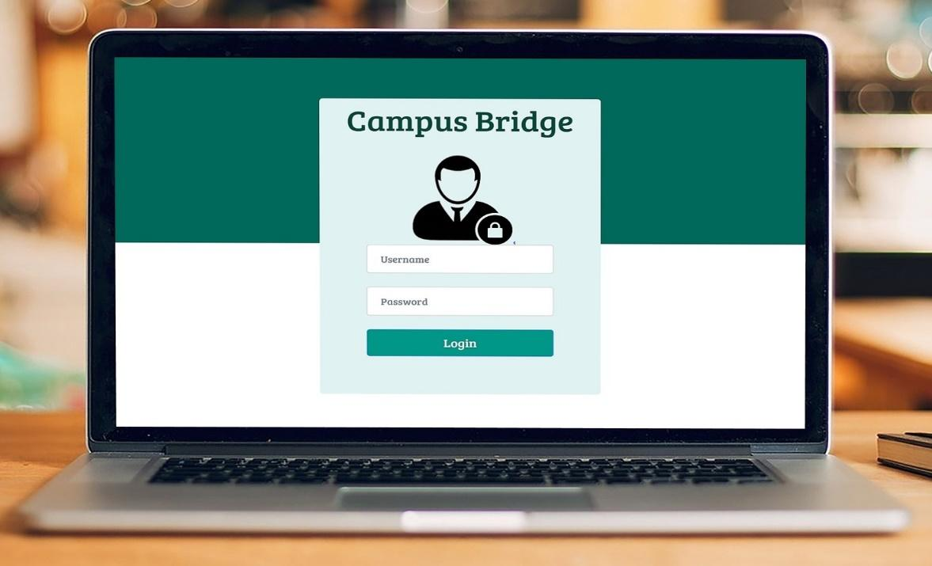

Snapshot 8.1: Admin Login Page

The above snapshot shows the first page of the web portal provided to the admin, which is the Login page for the admin. This page requests for the credentials required to authenticate the admin and successfully proceed to the Home page of the web portal.

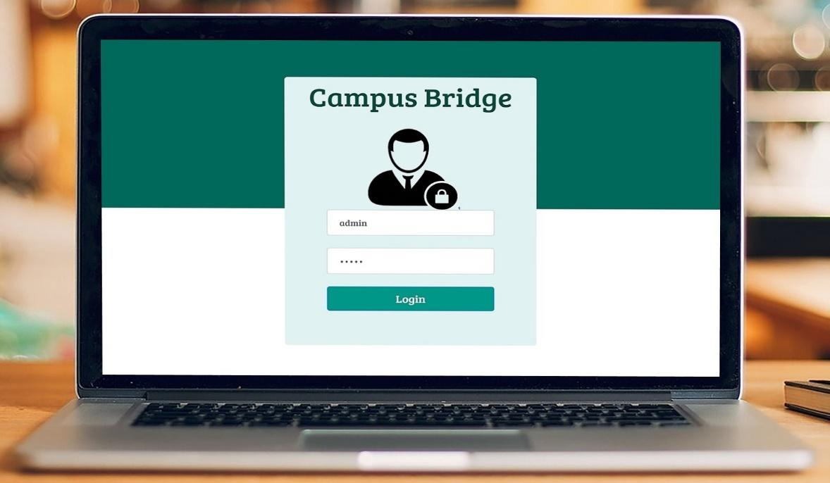

Snapshot 8.2: Admin Login Page with Credentials

Department of CSE, RNSIT2017-2018 Page 60

Chapter 8IoT Based Smart Campus

This above snapshot shows the login page after entering the credentials i.e. username and password by the admin. On pressing the Login button, it checks for the valid username and corresponding password.

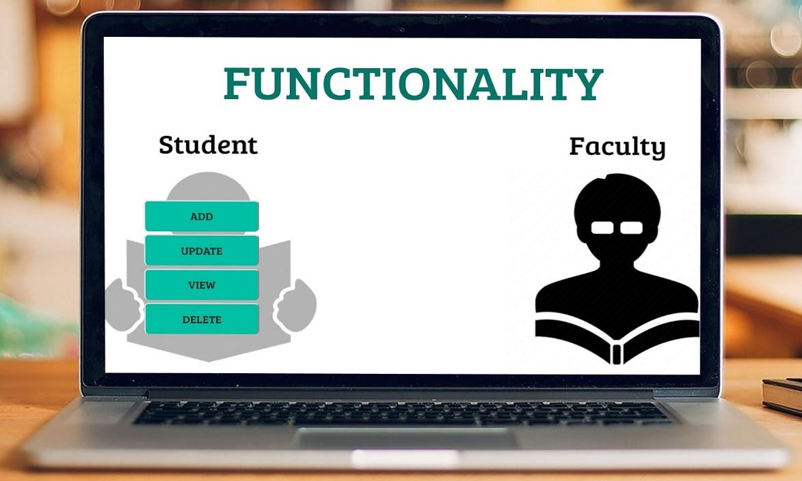

Snapshot 8.3: Functionality Page

This above snapshot shows the admin functionality page where the various options of insertion, deletion, updating and viewing of both the students and faculties is present. This page represents the front end of CRUD functionality provided to the admin.

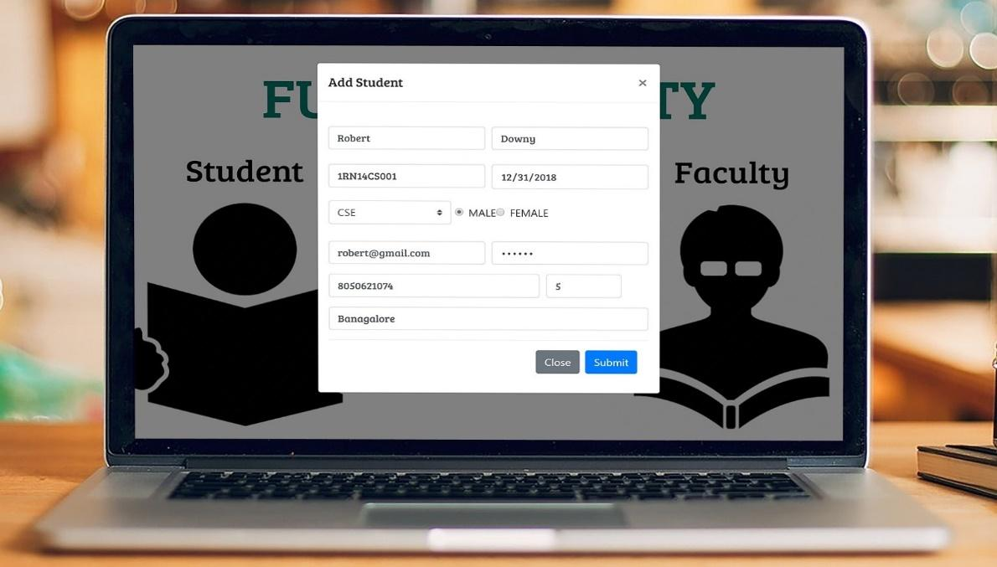

Snapshot 8.4: Add New Student Functionality

Department of CSE, RNSIT2017-2018 Page 61

Chapter 8IoT Based Smart Campus

This above snapshot shows the modal, which appears on selecting the ADD option in the student, section of the functionality page. This modal allows adding the required student record in the corresponding fields, which on submission would be stored in the database. Validation of these fields in the form have been handled, hence these student record stored are all valid entries.

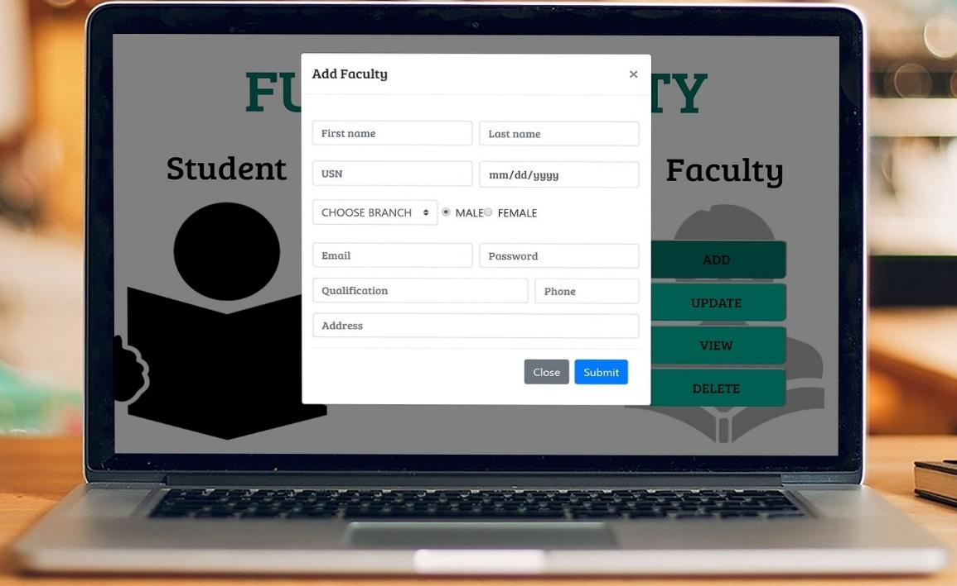

Snapshot 8.5: Add New Faculty Functionality

This above snapshot is similar to the add student functionality with the corresponding fields changed according to the faculty details. The same faculty details stored in the database can be retrieved for the various other requirements in the system.



Snapshot 8.6: Success Page

Department of CSE, RNSIT2017-2018 Page 62

Chapter 8IoT Based Smart Campus

This above snapshot shows the success page, which confirms the successful addition, deletion or updating done by the admin in either the student or faculty record.

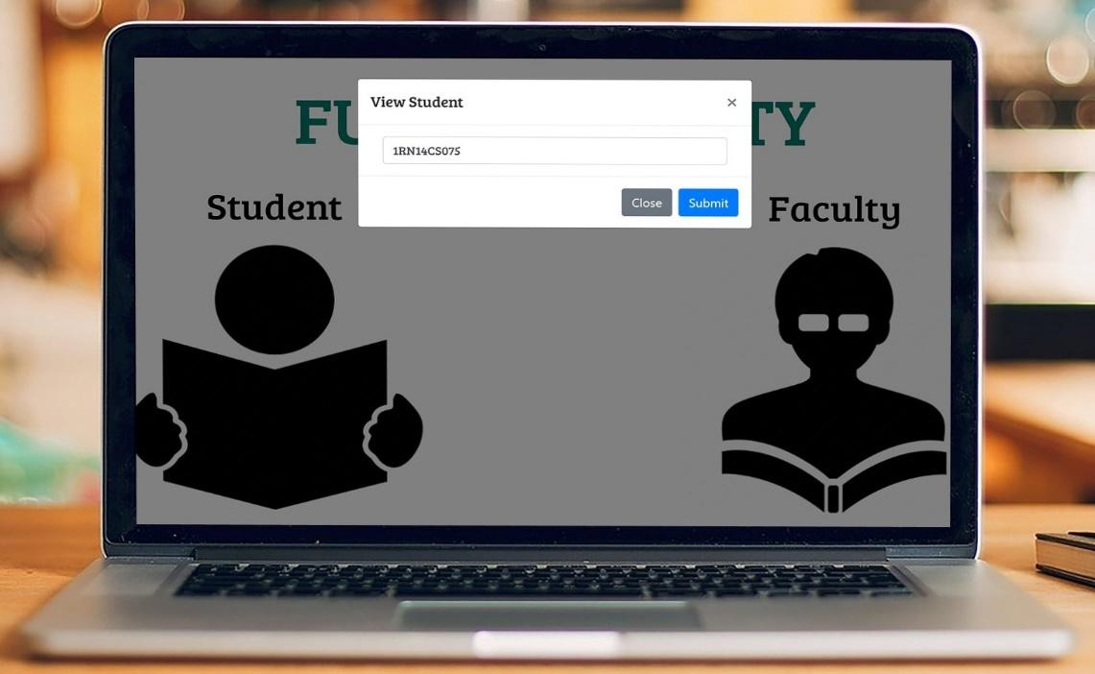

Snapshot 8.7: View Student Functionality

This above snapshot shows the view student modal which appears on selecting the view option in the student section. This requires the USN of the student that retrieves the corresponding record of the student stored in the database.

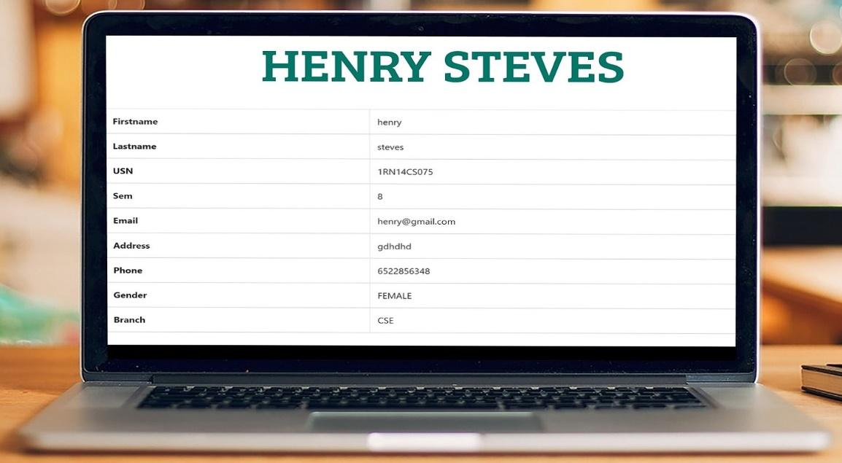

Snapshot 8.8: Student Details Page

Department of CSE, RNSIT2017-2018 Page 63

Chapter 8IoT Based Smart Campus

This snapshot shows the retrieved student details from the database by the USN of the student as shown above.

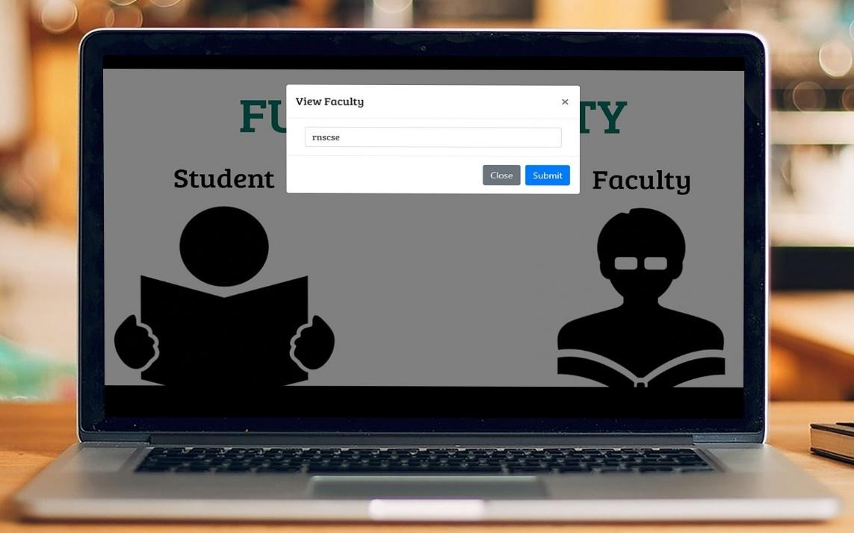

Snapshot 8.9: View Faculty Details Functionality

This above snapshot shows the view faculty modal which appears on selecting the view option in the faculty section. This requires the USN assigned to the faculty that retrieves the corresponding record of the faculty stored in the database.

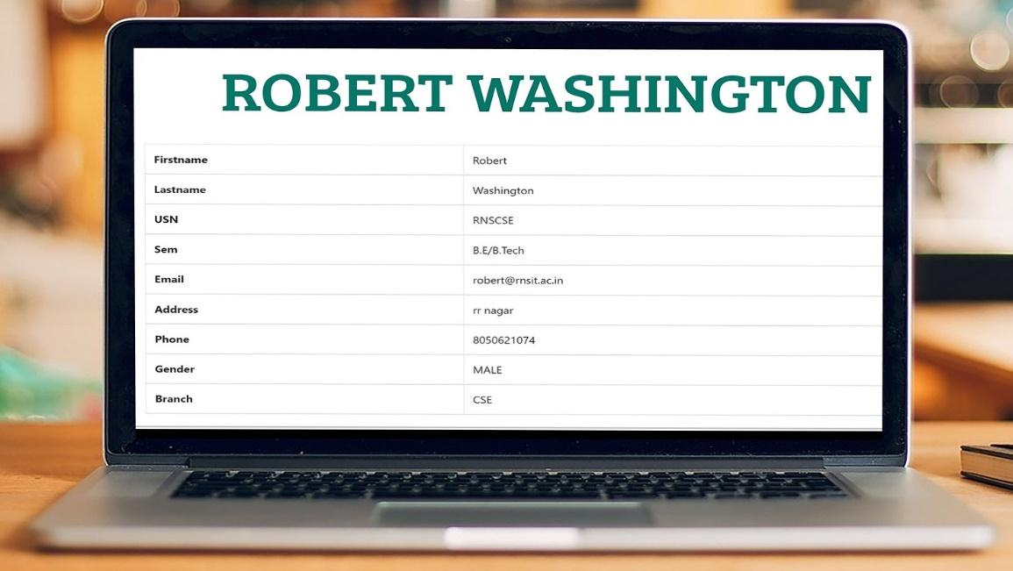

Snapshot 8.10: Faculty Details Page

Department of CSE, RNSIT2017-2018 Page 64

Chapter 8IoT Based Smart Campus

This above snapshot shows the corresponding details of the USN of the faculty given in the above modal. This shows that the USN is the primary key of the records of the students and faculties stored in the database.

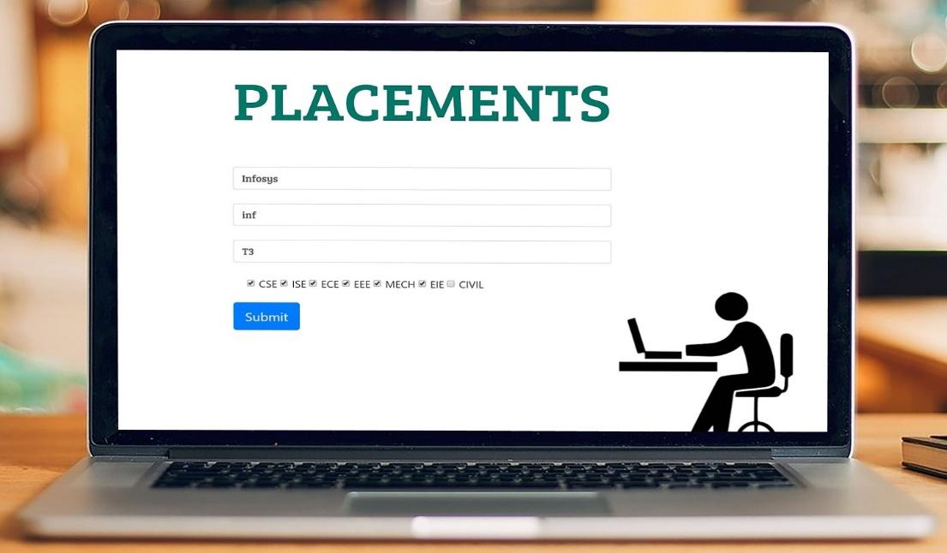

Snapshot 8.11: Placement Details Functionality

This above snapshot shows the placement functionality page which is also handled by the admin. This functionality allows the various companies along with their required eligibility criteria such as branches, overall minimum aggregate and as well as the tier under which the company falls in place. This allows for a much easier access to the information various companies students are eligible to apply for.

Department of CSE, RNSIT2017-2018 Page 65

Chapter 8IoT Based Smart Campus

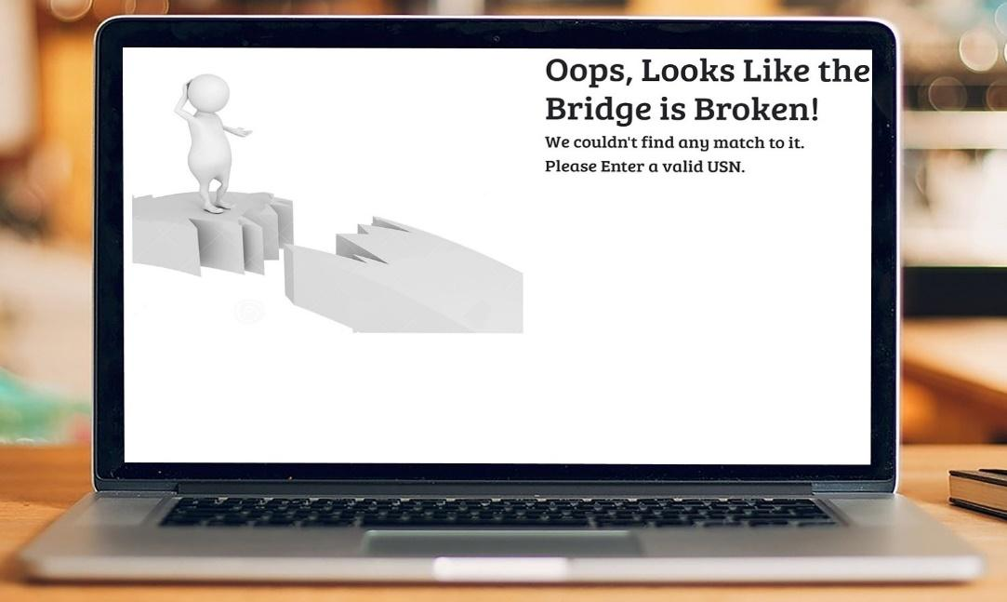

Snapshot 8.12: Error Page

This above snapshot shows the error page that handles any uncertain conditions such as unable to access the required details, USN not found, etc. This page allows the admin to know where the problem is present and rectify it.

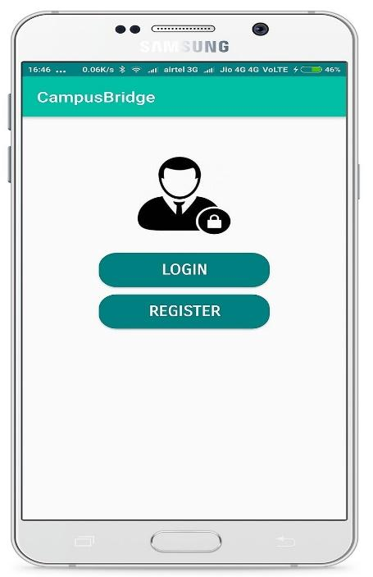

Snapshot 8.13: Welcome page

This snapshot shows the first screen which appears on opening the Campus Bridge app in an Android smartphone. This page provides the options of login or register to the student or faculty.

Department of CSE, RNSIT2017-2018 Page 66

Chapter 8IoT Based Smart Campus

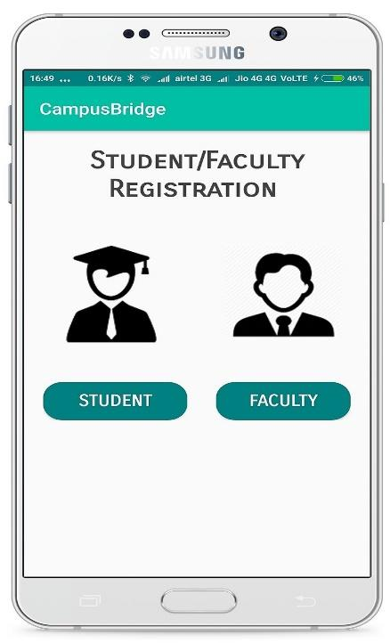

Snapshot 8.14: Registration Functionality

This snapshot shows the main registration page on installing the app and for usage of the app. This functionality allows for the separate registration as a student or as a faculty.

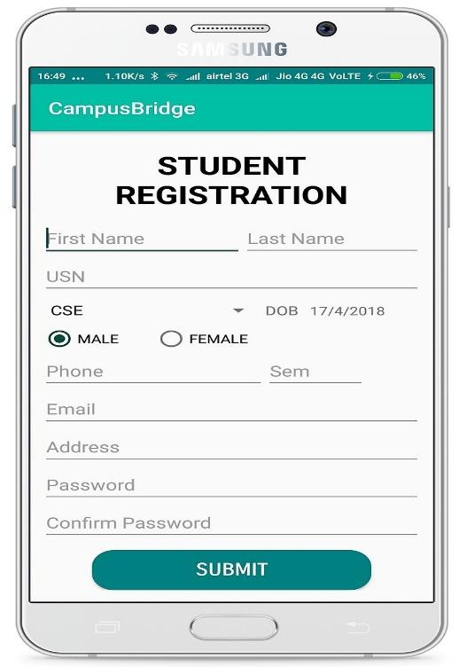

Snapshot 8.15: Student Registration Form

Department of CSE, RNSIT2017-2018 Page 67

Chapter 8IoT Based Smart Campus

This snapshot shows the student registration form page which needs to be filled out by the student so as to register himself in order to login to his portal in the app. This form collects all the required details from the student to match it with the internal records of the same student, after which the access will be provided.

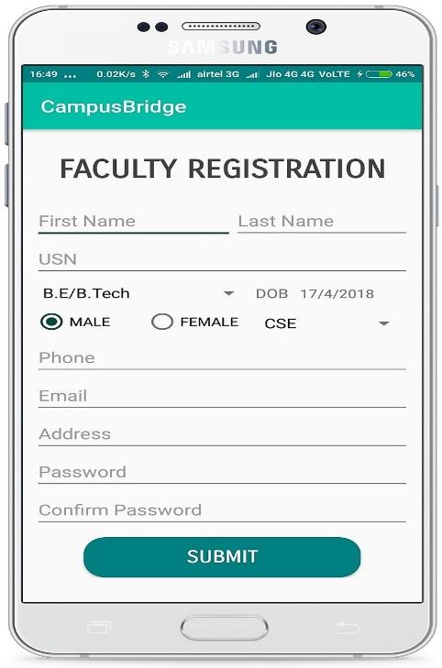

Snapshot 8.16: Faculty Registration Form

This snapshot shows the faculty registration form page that has the same functionality as above but provided for the registration of faculty.

Department of CSE, RNSIT2017-2018 Page 68

Chapter 8IoT Based Smart Campus

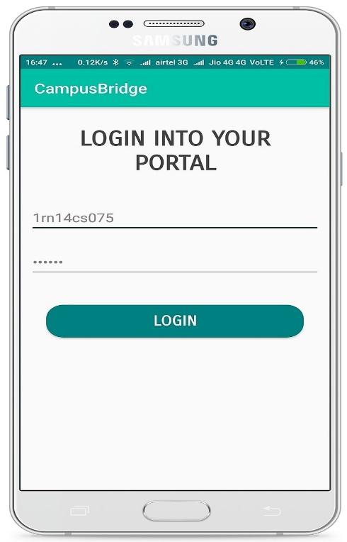

Snapshot 8.17: Student Login Functionality

This snapshot shows the student login page in the app where the credentials given during registration phase needs to be given. This provides security from unauthorized access to student-related information. On successful Login, it redirects to the student portal where the various functionalities of the app are available.

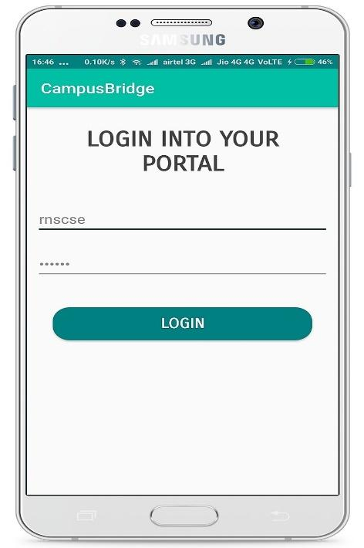

Snapshot 8.18: Faculty Login Functionality

Department of CSE, RNSIT2017-2018 Page 69

Chapter 8IoT Based Smart Campus

This snapshot shows the faculty login page in the app that is very similar to the student login page except that it is for the faculty.

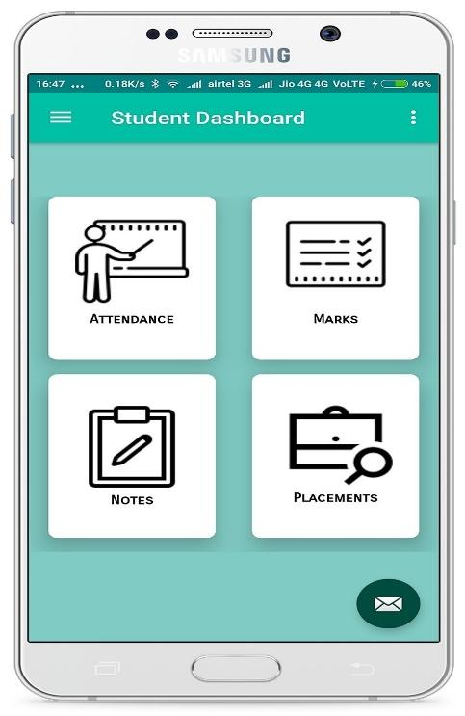

Snapshot 8.19: Student Home Portal

This snapshot shows the various options available in the student portal of the app. Some of the functionalities include checking attendance for each subject, internal marks of each subject, downloading various notes uploaded by faculties, placement details of companies the student is eligible for, etc.

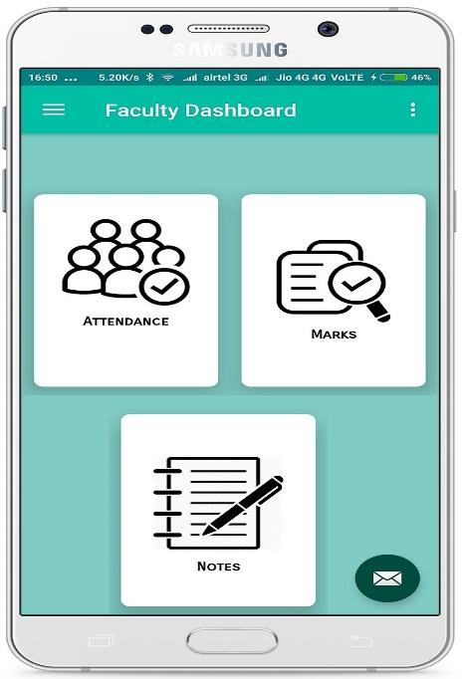

Snapshot 8.20: Faculty Home Portal

Department of CSE, RNSIT2017-2018 Page 70

Chapter 8IoT Based Smart Campus

This snapshot shows the various options available in the faculty home portal. Some of these functionalities include attendance confirmation, marks updation for each student and notes uploading for the subject handled, etc.

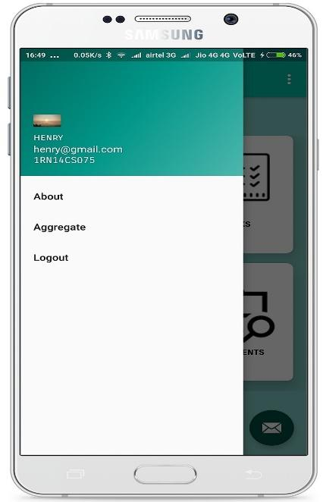

Figure 8.21: Student Portal Side Menu View

This snapshot shows the drawer menu available on clicking in the hamburger icon in the login home portal. This drawer shows the name of the registered student, USN as well as the email-id. It also includes the information such as aggregate calculation, Logout option etc.

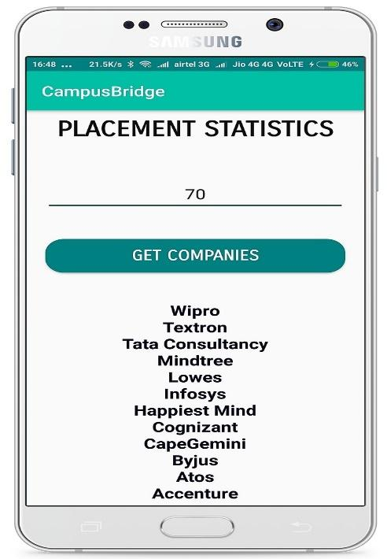

Snapshot 8.22: Student Placement Eligibility List

Department of CSE, RNSIT2017-2018 Page 71

Chapter 8IoT Based Smart Campus

This snapshot shows the various companies to which the student is eligible to apply for using the data from the placement board in the college. This makes the applying to companies and placement department activities much easier and less-time consuming.

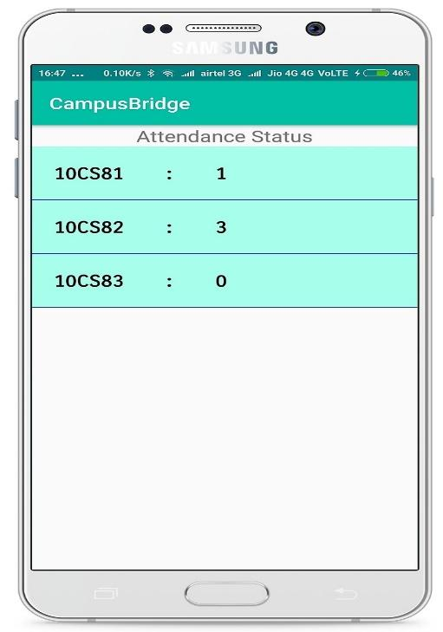

Snapshot 8.23: Student Attendance Status

This snapshot shows the class attended per subject by the logged in student in the app. Each time taking class attendance is over, and then the corresponding attendance values are refreshed at the end of the period. This also provides a cross verification which ultimately leads to better efficiency in the system.

Department of CSE, RNSIT2017-2018 Page 72

Chapter 8IoT Based Smart Campus

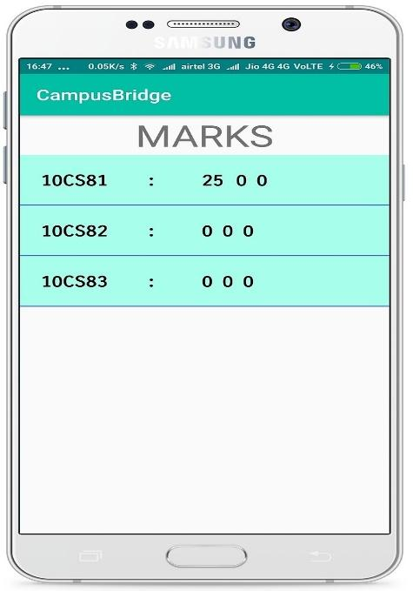

Snapshot 8.24: Student Internal Marks details

This snapshot shows the various internal marks scored by the student in various subjects in the particular semester. This shows the order of the marks according to the internal test. Most of the marks are updated by the faculty for the particular student USN.

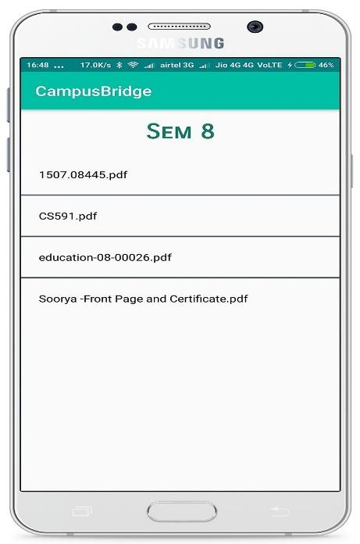

Snapshot 8.25: Student Notes Access Page

This snapshot shows the various notes uploaded by various faculties that can be downloaded by the student based on his requirements. These notes are organized and made available for each student based on his current semester retrieved from the registration details.

Department of CSE, RNSIT2017-2018 Page 73

Chapter 8IoT Based Smart Campus

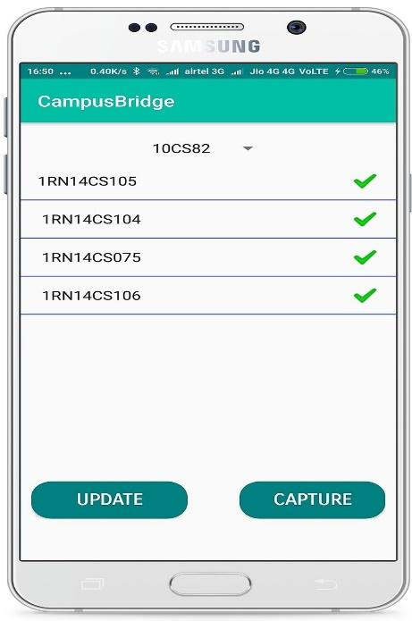

Snapshot 8.26: Attendance Confirmation Page

This snapshot shows the Attendance Confirmation Page that is a part of the attendance functionality in the Faculty app. This page allows for the faculty updates opening the camera app required to capture the photo of the class for image processing and according to the tally between RFID status and this count, the attendance.

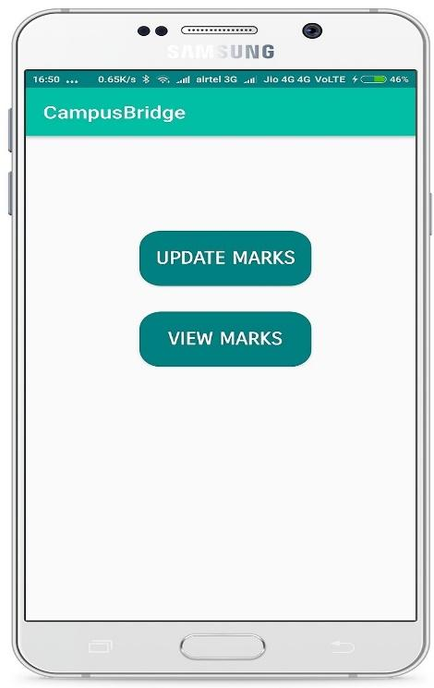

Snapshot 8.27: Faculty Internal Marks Updating

Department of CSE, RNSIT2017-2018 Page 74

Chapter 8IoT Based Smart Campus

This snapshot shows the faculty app’s internal marks updating page that provides them with the functionality of updating the marks scored by a student directly under his USN for that subject for any of the internals. These updated marks will be applied in the database and can be viewed from the marks section of the student app.

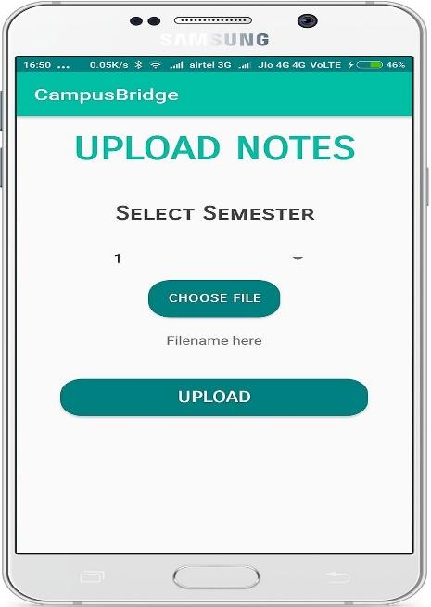

Snapshot 8.28: Notes Upload Functionality

This snapshot shows the notes upload functionality page available in the faculty app that provides the faculty a window to upload notes that are then segregated according to their mentioned semesters.

Department of CSE, RNSIT2017-2018 Page 75

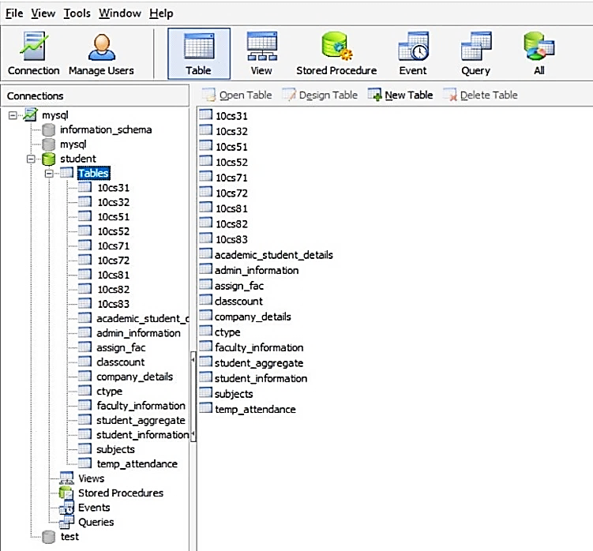Chapter 8IoT Based Smart Campus

Snapshot 8.29: Database tables

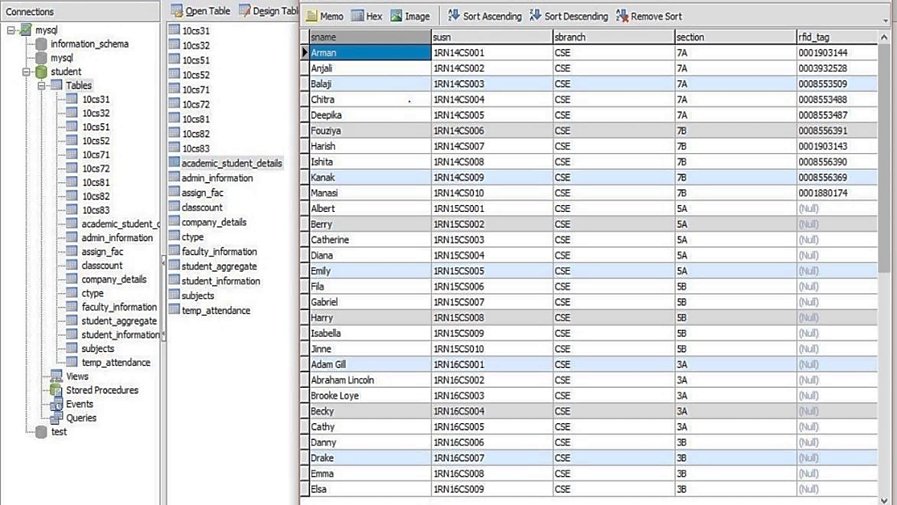This snapshot shows the various MySQL DB tables used to hold the various records of students, faculties, placement details, etc. These tables are queried based on the functionalities requirements so as to filter the required data and display it accordingly in our user interface.

Snapshot 8.30: Student Information Table

This snapshot shows the Student Information table which contains various fields corresponding to the various details collected form the students. This table is used to query various student information and also form the base table for various functionalities.

Department of CSE, RNSIT2017-2018 Page 76

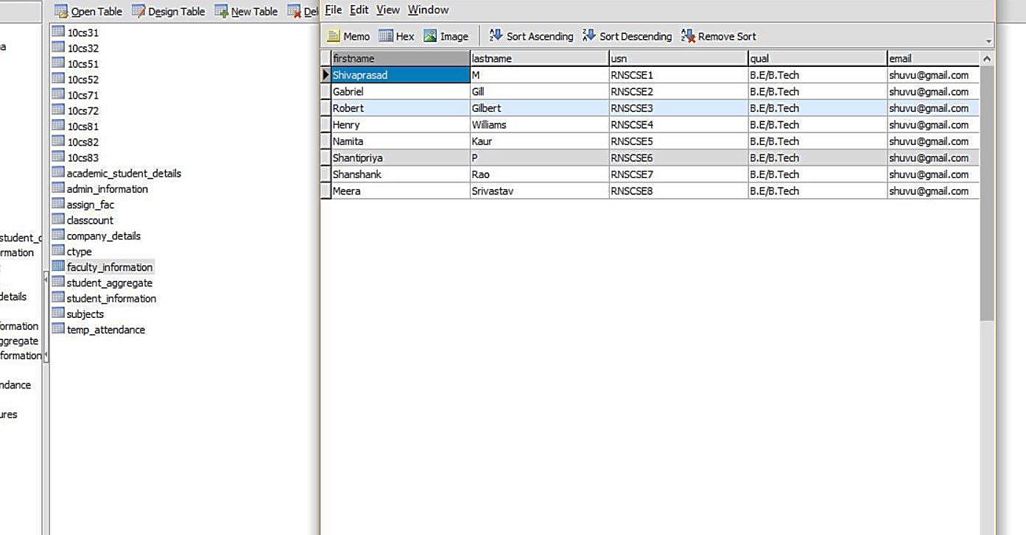Chapter 8IoT Based Smart Campus

Snapshot 8.31: Faculty Information Table

This snapshot shows the various faculty information stored by the database with various fields such as Name, USN, E-Mail, etc so as to establish. Hence, this table is usually queried by the various functionalities related to faculty.

**8.5 Data Analysis**

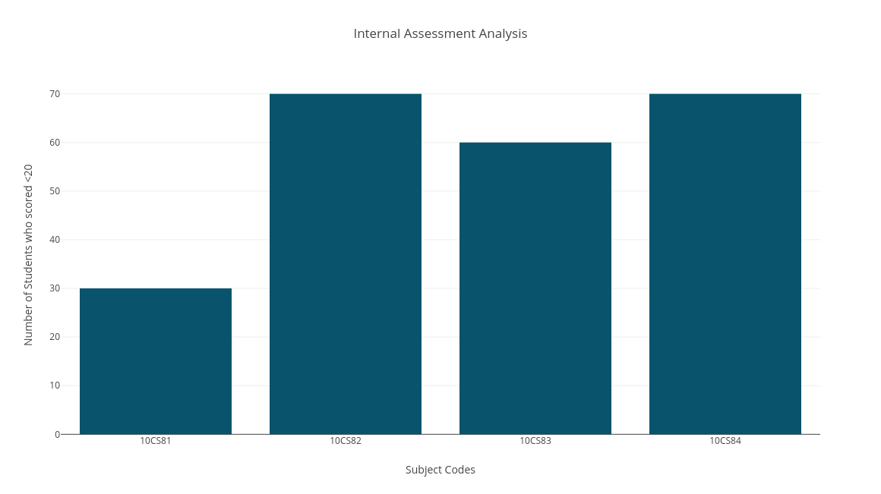

Graph-1: Internal Assessment Marks analysis

Department of CSE, RNSIT2017-2018 Page 77

Chapter 8IoT Based Smart Campus

This graph represents the IA marks analysis for each subject for a particular sem. X-axis represents Subject codes and Y-axis represents Number of students who have scored 20 or below. This will help in analyzing student's overall subject weakness and necessary steps can be taken in order to improvise.

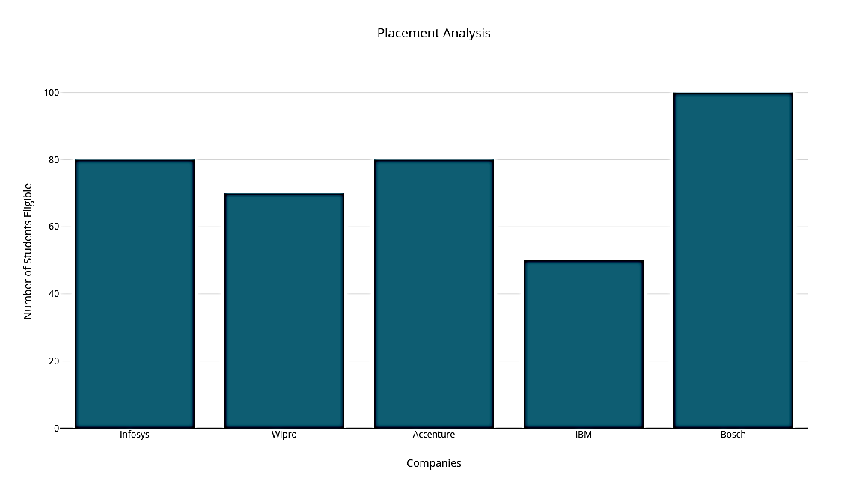

Graph-2: Placement analysis

This graph represents the placement analysis for each company. X-axis represents companies and Y-axis represents number of students eligible. This can help in analyzing students count for a company which can be used for betterment of placement in college.

Department of CSE, RNSIT2017-2018 Page 78

Chapter 8IoT Based Smart Campus

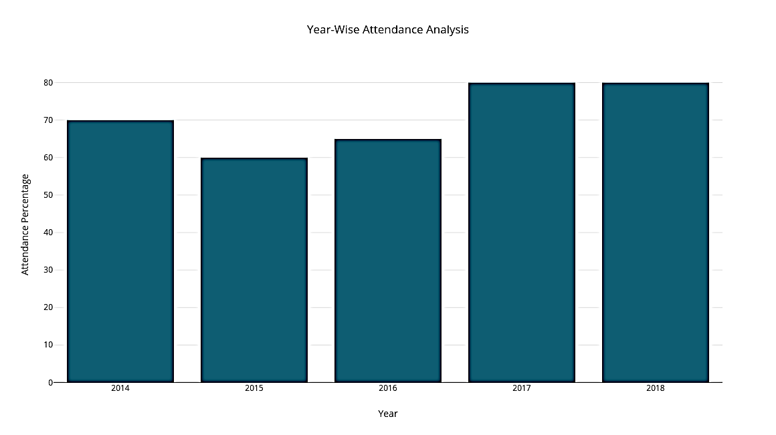

Graph -3: Attendance Percentage analysis

This graph represents the average attendance percentage for a single subject over a period of 5 years. X-axis represents the years, and Y-axis represents attendance percentage which can help in analyzing the student’s interest in that subject. Similar graphs can be represented through our data which is collected and can be used for performance analysis which will in turn help the department to improvise on those areas.

Department of CSE, RNSIT2017-2018 Page 79

**Chapter 9**

**CONCLUSION**

As we are running towards a much smarter and technology driven world, where manual work has become a thing of the past, our proposed Campus Bridge project is definitely going to be a step in the right direction. It will not just provide efficient solutions to various day-to-day functionalities carried out in an educational institution, but also gives a scope to more technology driven approach to our educational system. Tablets will replace all the books, RFID tags will replace all ID cards, as digitalization takes over the way in which our colleges and institutions run. This project is not just about the end of the traditional ways of college working but more about the dawn of a new, modern and technology-driven approach to bridge the gap between students and campus. Our project aims to eliminate the current traditional way of record management. The proposed work reduces the time spent on the manual process. The performance is improved through a better reliable system that is proposed. The cost is also reduced as the labour wages are eliminated. In future, we can enhance our project by replacing the RFID USB reader which always needs to be connected with a system with a Wireless enabled RFID reader which is more efficient and makes the project more flexible and portable. Another scope of improvement can be done in the field of image processing by using a much more efficient method to detect faces even in low light shots. The current project also can be expanded in various other functionalities such as the library department, even hostel and parking allotment and management to monitor and regulate these in much more efficient way. We are also working upon bringing up our apps in various other platforms such as Windows, iOS, Firefox OS, etc. to enable a much wider reach to the project.

Department of CSE, RNSIT2017-2018 Page 80

**BIBLIOGRAPHY**

[1] Manual Required for Java Servlet and database handling URL: <https://www.javatpoint.com/>

[2] Firebase Cloud Messaging Service Manual URL: <https://firebase.google.com/>

[3] Herve Chabanne, Pascal Urien, Jean‐Ferdinand Susini., “RFID and the Internet of

Things”, Wiley Publications, pp. 57 - 218, New York, Mar 2013.

[4] Prof. Sagar Rajebhosale, Mr. Shashank Choudhari, Mr. Sachin Patil, Mr. Akshay

Vyavahare, Mr. Sanket Khabiya., “SMART CAMPUS – An Academic Web Portal with

Android Application”., Volume 3, Issue 4, pp. 389 – 394, Apr. 2016.

[5] Lalit Mohan Joshi., “A Research Paper on College Management System. International

Journal of Computer Applications ”, (0975 – 8887) Volume 122 – No.11, July 2015.

[6] Chitresh S and Amit K., ”An efficient Automatic Attendance Using Fingerprint

Verification Technique”, International Journal on Computer Science and Engineering

(IJCSE),Vol. 2 No. 2, pp 264 - 269. Dec 2010.

[7] M.R.M.Veeramanickam, Dr. M. Mohanapriya., “IOT enabled Futurus Smart Campus

with effective E-Learning : I-Campus”, GSTF Journal of Engineering Technology(JET)

Vol.3 No.4, pp. 81 -87, Apr. 2016.

[8] C. E. Geoffrey, “Automatic Access Control System using Student’s Identification Card

based on RFID Technology”, Unpublished Thesis Faculty of Electrical Engineering,

University of Teknologi Malaysia, Jan 2012.

[9] Pranay Kujur and Kiran Gautam, "Smart Interaction of Object on Internet of Things",

International Journal of Computer Sciences and Engineering, Volume-03, Issue-02,

pp. 15 - 19, Feb -2015.

[10] Shalini Jain and Anupam Shukla., “Smart Card Application for Attendance Management System”, Advanced Computing, Networking and Informatics - Volume 1, pp.153-158, Jan 2014.

[11] KristianHentschel, DejiceJacob,Jerem Singer, and Matthew Chalmers , "Supersensors Raspberry Pi Devices for Smart Campus Infrastructure (short paper)", 2016 IEEE 4th International Conference on Future Internet of Things and Cloud ,Year:2016

[12] Marian Cata, "Smart University, a new concept in the Internet of Things" IEEE Conference Publications, Year:2016

[13] N. Sastra and D. Wiharta, "Environmental monitoring as an IoT application in building smart campus of Universitas Udayana", 2016 International Conference on Smart Green Technology in Electrical and Information Systems (ICSGTEIS), Vol.3, pp. 85-88, 2017.

[14] Anugerah Ayu and Barroon Ismaeel Ahmad, “TouchIn: An NFC Supported Attendance System in a University Environment”, International Journal of Information and Education Technology, Vol. 4, No. 5, pp. 448 – 453, October 2014

[15] “Intelligent Device-to-Device Communication in the Internet of Things”, Oladayo Bello, Member, IEEE, and Sherali Zeadally, Senior Member, IEEE, Dec 2013

[16] Akshara Jadhav, Akshay Jadhav, Tushar Ladhe and Krishna Yeolekar, “Automated Attendance System Using Face Recognition”, IRJET, Vol. 04, Issue 01, pp. 1467 – 1471, Jan 2017.